Teresa F. (Thomassie) Bautsch

May 31, 1923 – June 12, 2015

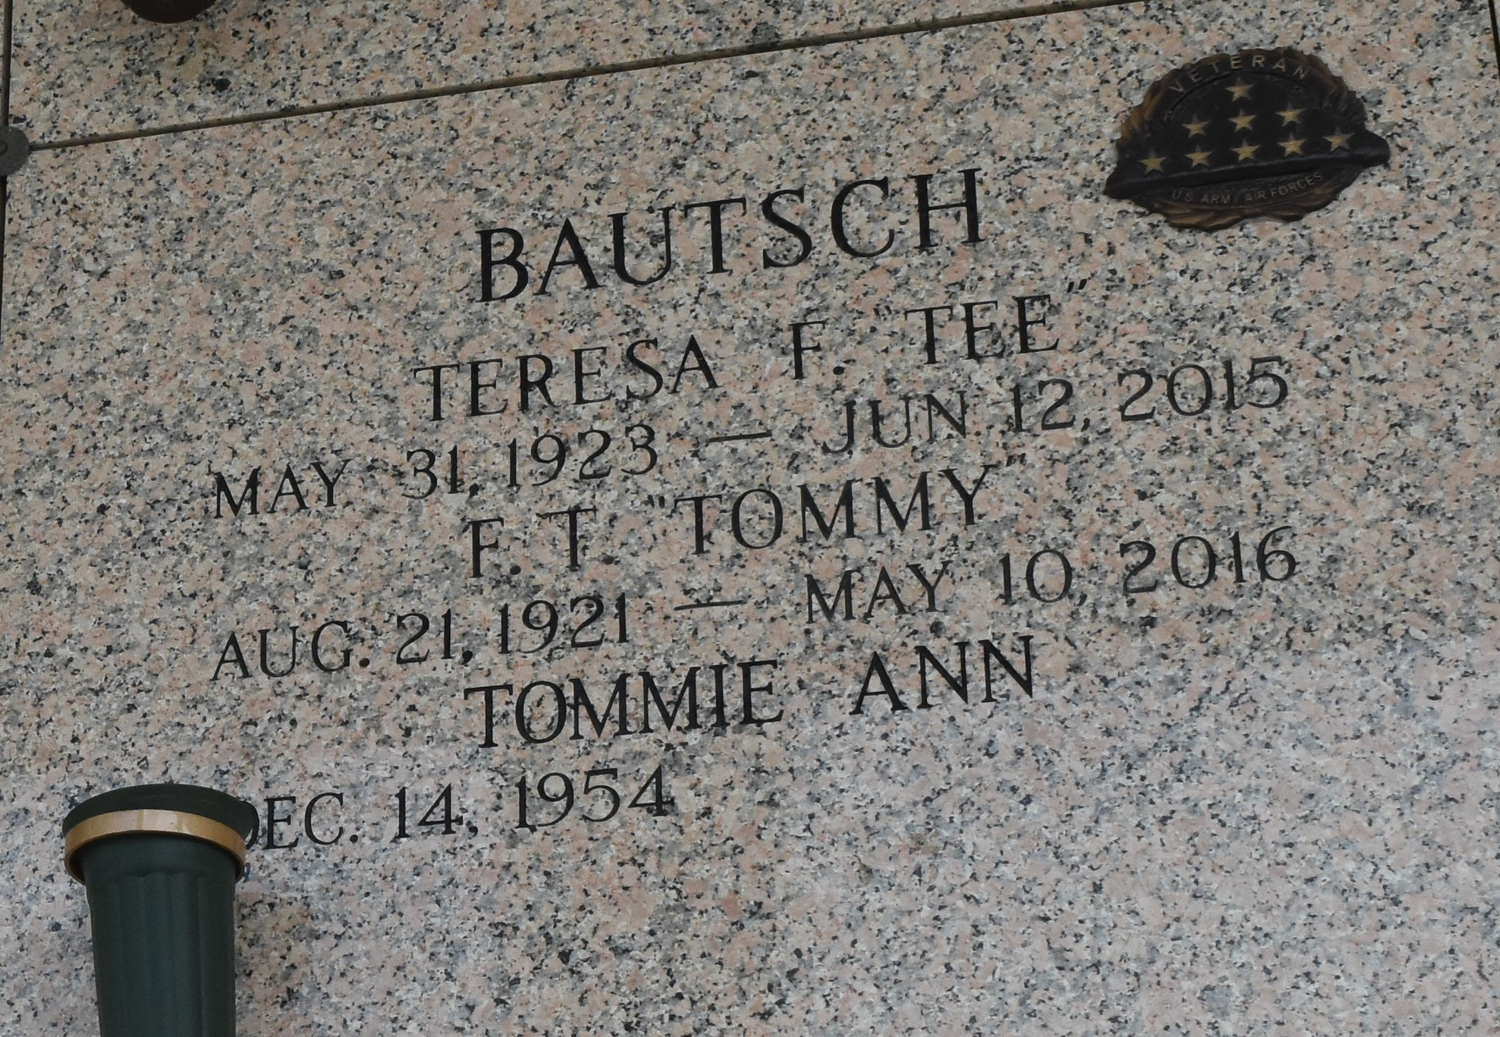

Teresa F. Bautsch, 92, passed away peacefully on Friday, June 12, 2015. She was a native of St. Amant and a resident of LaPlace. Bautsch was the beloved wife of F. Thomas Bautsch for over 60 years; mother of Mary A. Ford, Debra A. Navarre, Jo A. Giarrusso, Tommie A. Bautsch and Teresa A. Merritt; daughter of Belizare Thomassie and Regina Bourgeois Thomassie; sister of the late Percy Thomassie, Mildred Bourque, Mable Gautreau and Yvonne Bourgeois; and grandmother of Rodger Jr., Cynthia, Thomas, James, Rachel, Rebecca, Renee, Carrie, Olivia, Jennifer, Eara, Graille and Ari. She is also survived by 23 great-grandchildren, two soon-to-be great-grandchildren, one greatgreat-grandchild and many nieces and nephews. She touched the lives of many through her work in the church and her community.

Relatives and friends are invited to attend the Funeral Mass at Ascension of Our Lord Catholic Church, 799 Fairway Dr. in LaPlace on Tuesday, June 16 at 11 a.m. Visitation will be held at the church from 9 to 11 a.m. Interment is in St. John Memorial Gardens Cemetery. Arrangements are being handled by Millet-Guidry Funeral Home. To view and sign the online guest book, visit milletguidry.com.

L'Observateur, LaPlace, Louisiana

Friday, June 12, 2015