Donald Lee Bigelow

October 11, 1956 – June 3, 2001

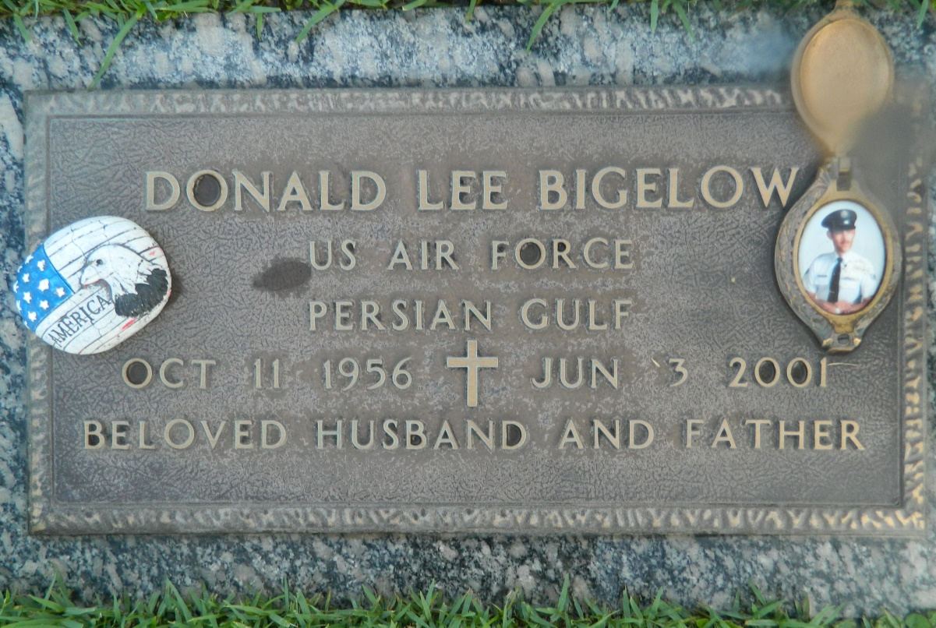

BIGELOW, DONALD L.

Died Sunday, June 3, 2001, at 1:45 a.m. He was the beloved husband of Sallie Whitehead Bigelow; father of Tara Bigelow; stepfather of Michel Cambry Jr., Kevin and Cari Gehegan and the late Steve Gehegan; son of Ronald Bigelow and the late Mary Jo Smith; brother of Randy and Trina Bigelow, Stanley and Robert Wheatley and Albert Smith; stepbrother of Barry and Glenn Entremont; and is survived by six grandchildren. He was 44, a native of Lima, Ohio, and a resident of Reserve. Relatives and friends of the family are invited to attend the funeral services at Millet-Guidry Funeral Home, 2806 W. Airline Highway, LaPlace, on Wednesday June 6, 2001, in the funeral home chapel at 10 a.m. Burial in St. John Memorial Gardens, LaPlace. Visiting from 5 p.m. to 10 p.m. Tuesday and 8 a.m. until services Wednesday.

Advocate, The (Baton Rouge, LA)

Tuesday, June 5, 2001

Contributed by Jane Edson