Rose Mary (Gerard) Bolden
1964 – December 14, 2018

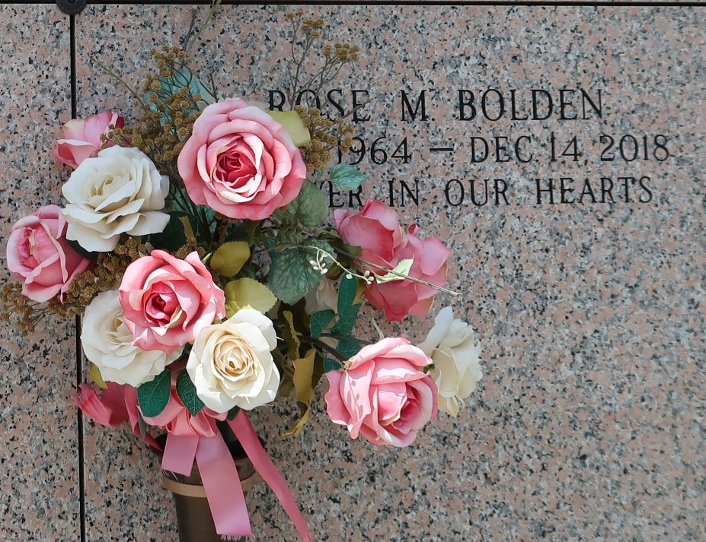

Rose Mary G. Bolden on Friday, December 14, 2018 at Ochsner Medical Center, Jefferson, LA. Daughter of Isabella H. Gerard and the late Earl Gerard, Sr. Mother of Emmanuel Gerard. Sister of Lurline Warren, Joleen Patterson (Ricky), Sadie Harper (Troy), Geraldine, Racheal, Apostle Earl (Deborah), Michael (Shawn), Gary (Christie), John and Troy (Corren) Gerard, the late Gerry Gerard and Robin Ann Smith. Also survived by a host of nieces, nephews, cousins, other relatives and friends. Age 54 years. A native and resident of LaPlace, LA. Relatives and friends of the family, also pastors, officers and members of Spirit of Liberty Full Gospel Church and all neighboring churches are invited to attend the Funeral Service at Spirit of Liberty Full Gospel Church, 609 Main Street, LaPlace, LA on Saturday, December 29, 2018 at 10:00 AM. Rev. Earl Gerard, Pastor, Officiating. Interment St John Memorial Garden Cemetery, Laplace, LA. Visitation at the above named church from 9:00 AM until Service Time. SERVICED BY ROBOTTOM
The Times-Picayune, New Orleans, Louisiana
Dec. 24 to Dec. 28, 2018.

