Marilyn (Ridings) Bombardier

July 6, 1936 – July 14, 2018

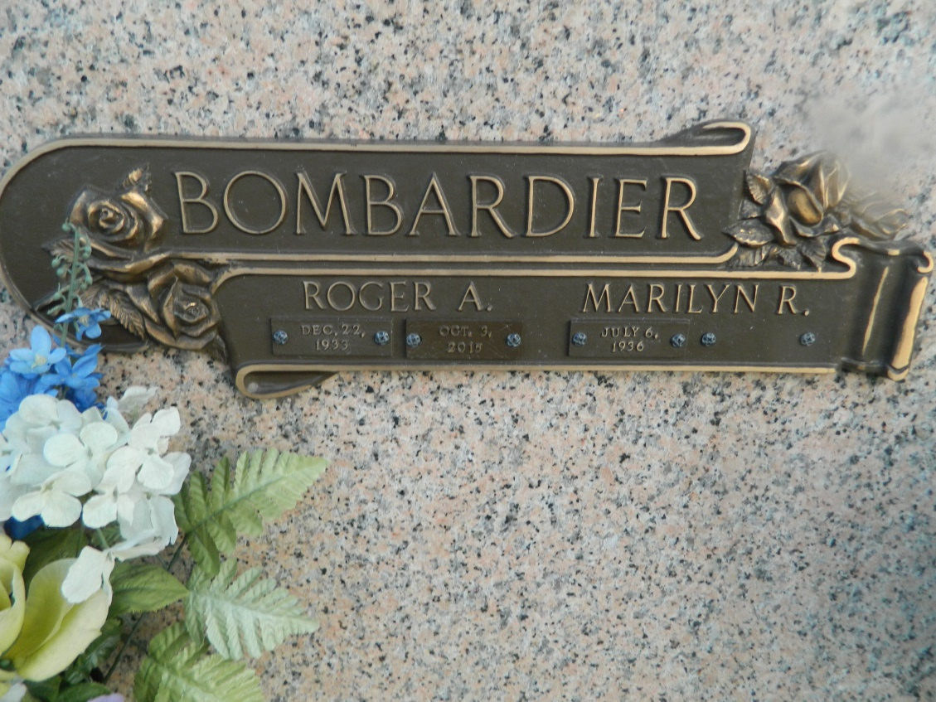

Marilyn Ridings Bombardier, passed away on Friday morning, July 14, 2018 with her three loving children, Linda Bombardier, Laura B. Couvillion and John Bombardier, by her side. She was born in Bridgeport, Connecticut and resided in Metairie, Louisiana since 1962. Mrs. Bombardier attended Lauralton Hall, a college preparatory school for women. After graduation in 1954, she received a scholarship to the University of Bridgeport where she received her Associate's degree and was voted homecoming queen. A member of St. Philip Neri Catholic Church since 1970, she enjoyed teaching catechism classes and volunteering as a room mother as well as for Christmas charity events. She was an accomplished seamstress, card player and horseback rider. She loved animals, especially her loyal dog Taffy. She enjoyed boating and spending time with family and friends at her condominium in Gulf Shores, Alabama.

Preceded in death by her parents, Edmund J. Ridings and Mary Sabo Ridings, and her beloved husband of 57 years, Roger A. Bombardier. She is survived by five grandsons that she adored - Morgan Bourne, Bryce Bourne, Ross Bourne, Cole Couvillion, and Luke Couvillion.

Family and friends are invited to wear pink in celebration of Marilyn's life. Relatives and friends are invited to attend a funeral mass at LEITZ-EAGAN Metairie, 4747 Veterans Memorial Boulevard, on Saturday July 21, 2018 at 1:00 pm. Visitation will begin at 11:00 am. Interment will follow in St. John Memorial Gardens, LaPlace.

TheNewOrleansAdvocate.com

July 18 to July 21, 2018