Roger A. Bombardier
December 22, 1933 – October 3, 2015
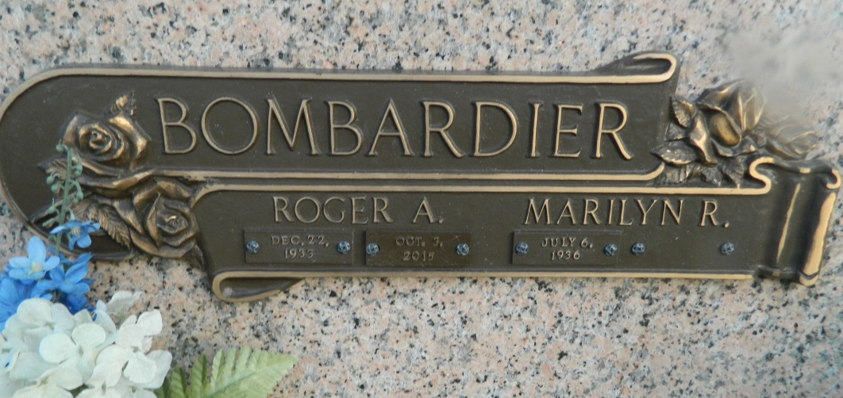

Roger A. Bombardier, a retired Special Agent of the Federal Bureau of Investigation, passed away on Saturday evening, October 3, 2015. Mr. Bombardier was born in Pawtucket, Rhode Island and resided in Metairie since 1962. He served in the United States Air Force during the Korean War. After his discharge from the Air Force, he attended St. John's University, Jamaica, Long Island, New York, where he received his Bachelor of Arts Degree and the University of Connecticut School of Law, Hartford, Connecticut, where he received his Juris Doctor Degree. After his retirement from the F.B.I., Mr. Bombardier founded the Investigative Consultant Company of RB & Associates, Inc. of which he was the President. A lifelong member of St. Philip Neri Catholic Church, he was a Past President of the Men's Club, a Minister of Hospitality, and a Eucharistic Minister. He also served as a Eucharistic Minister at the Metairie Healthcare Center and East Jefferson Hospital. Mr. Bombardier was a member of the Society of Former Special Agents of the F.B.I., the St. Philip Neri Men's Club, the Krewe of Caesar and served for 14 years on the Board of Directors of the Gulf Shores Surf & Raquet Club, Gulf Shores, Alabama.
He is survived by his wife, Marilyn Ridings Bombardier. They celebrated their 50th Anniversary on August 16, 2008 in Puerto Villarta, Mexico. Loving father of three children – Linda Bombardier, Laura Bombardier Couvillion and John E. Bombardier, son-in-law Robert Couvillion and the beloved grandfather of five grandsons – Morgan Bourne, Bryce Bourne, Ross Bourne, Cole Couvillion and Luke Couvillion.
Relatives and friends are invited to attend a funeral Mass at LEITZ-EAGAN Metairie, 4747 Veterans Memorial Boulevard, on Saturday morning, October 10, 2015 at 11:00. Visitation will begin at 9:00. Interment will follow in St. John Memorial Gardens, LaPlace. An online guestbook is available at www.leitzeaganfuneralhome.com.

TheNewOrleansAdvocate.com
Oct. 6 to Oct. 8, 2015

