Lawrence "Larry" J. Boudreaux

August 29, 1944 - November 26, 2018

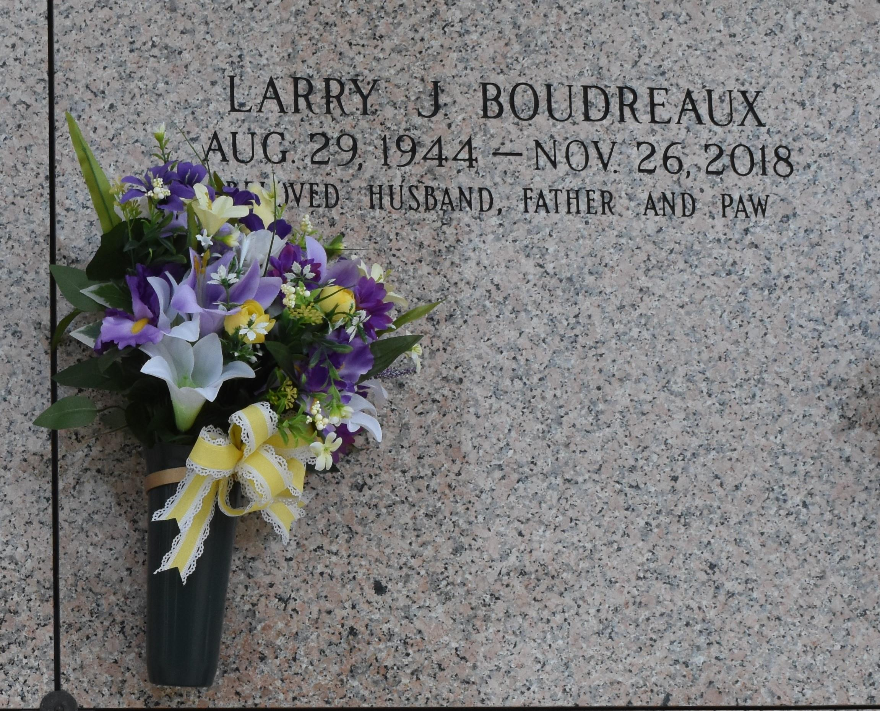

Lawrence “Larry” J. Boudreaux passed away peacefully surrounded by his loving family on Monday, November 26, 2018 at the age of 74. He was a native of Labadieville, LA and a longtime resident of LaPLace, LA. He served during peace time in the U.S. Army and later retired after 37 years of employment with Dupont.  
 Larry was an active member of the Knights of Columbus 5935, VFW Post 3337 and a parishioner of St. Joan of Arc Catholic Church.  
 Beloved husband of the late Rebecca Clause Boudreaux. Loving father of Scott G. Boudreaux (Pam), Angelle B. Aydell (Russell) and Renee B. Scott (Henry). Grandfather of Shane Boudreaux (Rebecca), Patrick Boudreaux, Russell Aydell III, Rhonda Scott and Lily Scott. Son of the late Milton Gaston Boudreaux and Mathilde Navarre Boudreaux. Brother of Ruby B. Breaux (Leonard), Peggy B. Montalbano (the late, Jake), Dr. Leroy Boudreaux (Brenda), Dolores B. Folse (Alfred) and the late Nolan Joseph Boudreaux (Carmen), Milton Boudreaux (Petsie), Rosalie B. St. Germain (CJ) and Catherine B. Gaudet (Russell). Also survived by many nieces and nephews. He was also preceded in death by his companion Daisy Keller Rushing and is survived by her family, Lisa R. Swanson (Mike) and grandkids, Joy S. Breath (Nick) and Beth Swanson (Shane). Honorary Pallbearers will be the Senior members of the 1962 Assumption Mustang High School Football team.  
 The family would like to extend a special thanks to the staff of St. Catherine’s Hospice for the special care that they gave for our loved one.  
 Relatives and friends are invited to attend the Visitation at Millet-Guidry Funeral Home, 2806 W. Airline Hwy., LaPlace on Thursday, November 29, 2018 from 5:00 p.m. to 8:00 p.m. and at St. Joan of Arc Catholic Church, 529 W. 5th St., LaPlace on Friday, November 30, 2018 from 9:30 a.m. to 12:00 p.m. with the Funeral Mass to immediately follow at 12:00 p.m. Interment in St. John Memorial Gardens Cemetery.

Millet-Guidry Funeral Home, LaPlace, Louisiana