Marjorie “Margie” (Duhe) Boudreaux

April 14, 1933 – February 2, 2002

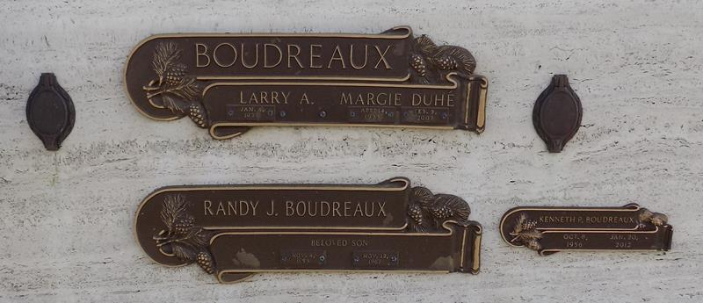

Mrs. Margie Duhe' Boudreaux, age 68 years, a native of LaPlace, LA and resident of Ponchatoula, LA, died on Saturday, February 2, 2002 at her residence. Survivors: husband, Larry A. Boudreaux, Ponchatoula, LA; 3 daughters: Susan B. Ross, Albany, LA, Lisa B. Gaudet, Ponchatoula, LA and Shelly B. Wagner, Albany, LA; 3 sons: Kenneth P. Boudreaux, Steven A. Boudreaux and Eric L. Boudreaux all of Ponchatoula, LA; 13 grandchildren, 5 greatgrandchildren and 2 brothers: Harold "Dago" Duhe', Marrero and Oswald Duhe', LaPlace, LA. Preceded in death by, parents: Willie and Leonie Millet Duhe'; son, Randy J. Boudreaux; 6 brothers: Willie "Bill" Duhe', Jr., Dr. Henry Duhe', Harry Duhe', Paul Duhe', Peter Duhe' and Leon "Tricke" Duhe' and 2 sisters: Geneviere D. LaBiche and Joyce Duhe'.

Visitation at Harry McKneely, Ponchatoula, LA on Monday, February 4, 2002 from 10:00 a.m. until 1:15 p.m. Religious Services will begin at 1:30 p.m. on Monday at St. Joseph Catholic Church. Interment St. John Cemetery, LaPlace, LA. HARRY McKNEELY & SON FUNERAL HOME in charge of arrangements.

Times-Picayune, The (New Orleans, LA)

Sunday, February 3, 2002

Contributed by Jane Edson