Paul S. Braud Jr.

August 31, 1926 – May 17, 2002

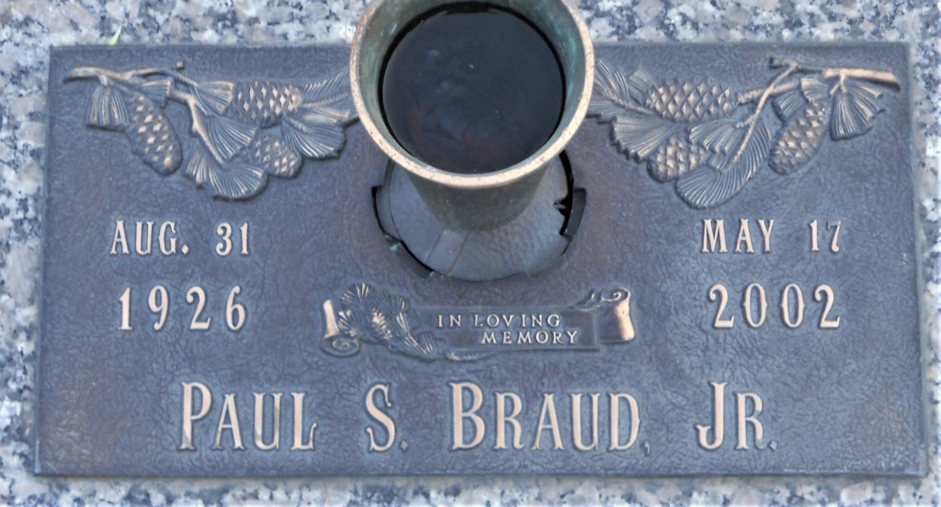

Photo by Team T Lo

Paul (Junior) Braud On Friday, May 17, 2002 At 4:00 A.M. Beloved Son Of The Late Sidney And Eline Braud. Brother Of James Breaux, Julia Rezach, Doris Becnel, Ruth Braud, And The Late Kermit Breaux. Also Survived By Nieces And Nephews. Age 75 Years. A Native Of Gonzales And A Resident Of Franklington, La For The Past 14 Years. Relatives And Friends Of The Family, Also Family From Springfield Community Group Home Are Invited To Attend Services. Visitation At Millet Guidry Funeral Home, 2806 West Airline Highway, Laplace On Saturday, May 18, 2002 From 9:00 A.M. To 10:00 A.M. Followed By Religious Services In The Funeral Home Chapel At 10:00 A.M. Burial In St. John Memorial Garden Cemetery, Laplace.

Times-Picayune, New Orleans, Louisiana

May 18, 2002