Huey Paul Breaud

September 19, 1935 – March 26, 2019

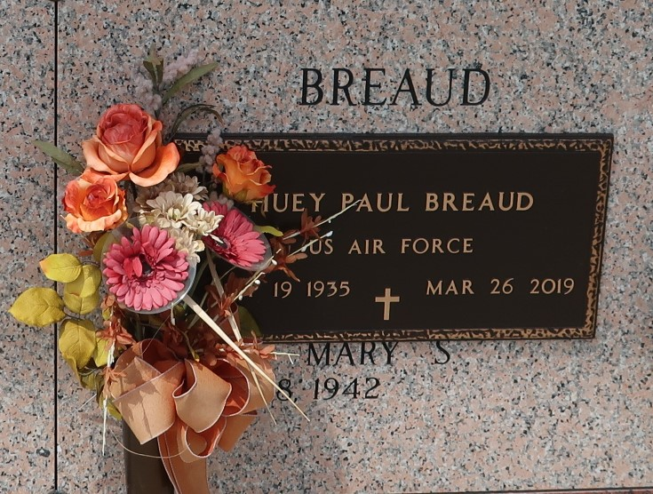

Huey Paul Breaud was born on September 19, 1935 and passed away at his home surrounded by his family on March 26, 2019 at the age of 83. He was a native of Gramercy and resided in LaPlace.

He is survived by his wife of 56 years, Mary Frances St. Martin; children, Glynn Breaud (Connie), Gary Breaud (Dana), Stacey Breaud Jenkins, Dawn Breaud Brady (Paul), and Donna Breaud (Larry); sister, Kathleen Deroche (Donald); and 12 grandchildren as well as 10 great grandchildren, numerous nieces, nephews, and cousins.

He was preceded in death by his parents, Robert S. Breaud and Ophelia Rodrigue Breaud; stepmother, Bessie Matherne Breaud; brothers, Clifford Breaud (Moguyneta), Larry Breaud (Eunice), Alfred Breaud (Dolly), Robert Breaud (Jeanette); and sisters, Pearl Braud (Octave), and Thelma Bailey (William).

A visitation in his honor will be held at Rose Lynn Funeral Home in Lutcher, La on Friday, March 29, 2019 from 6 to 9 p.m. Visitation will resume at St. Joan of Arc Catholic Church in LaPlace, La on Saturday, March 30, 2019 at 10 a.m. until a Mass of Christian Burial at 12 p.m. Burial will follow in the St. John Memorial Gardens Cemetery in LaPlace, La.

The family would like to give a special thank-you to Egan Home Health Hospice for all their help.

Rose Lynn Funeral Home, Lutcher, Louisiana