Lorraine Marie (Fagot) Brennan

October 11, 1911 – July 30, 1934

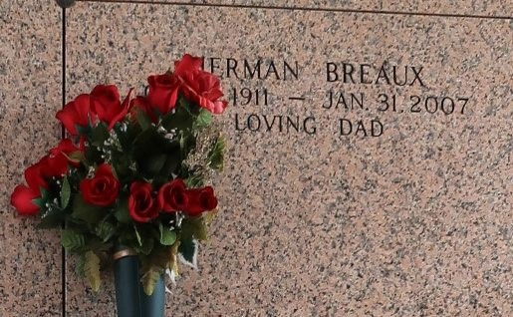

She was born July 30, 1934. She passed away following complications from vascular dementia and Parkinson's disease on October 7, 2014. She was a devoted Catholic Educator. She was a teacher and elementary school Principal. She was the founding Principal at Ascension of Our Lord Catholic School in LaPlace, and served there from 1980 through 1989. She was a long time parishioner of St. Joan of Arc Church in LaPlace and St. Joseph Church in Ponchatoula. She was most recently a parishioner at St. Theresa of Avila church in Gonzales, following her move to Magnolia Assisted Living in Gonzales, in April 2012. Interment in St. John Memorial Gardens.

Gonzales Weekly Citizen (Ascension, LA)

Thursday, October 16, 2014

\*\*\*\*\*

Lorraine Marie Fagot Brennan came into this world on July 30, 1934. She was the youngest of six children born to Lillian Marie Duplantier Fagot and Cornelius Lionel Fagot and Cornelius Lionel Fagot, Sr. She entered into eternal life following complications from vascular dementia and Parkinson's disease on October 7, 2014. She is survived by her loving children, Colleen Mary Brennan Labat (Darren) and Robert Joseph Brennan. Ourso Funeral Home of Gonzales, La., was in charge of arrangements.

Ascension Advocate, The (Louisiana)

Thursday, October 23, 2014

Both contributed by Jane Edson