Bernadine Janet (Hall) Brennecke

August 25, 1930 – February 21, 2001

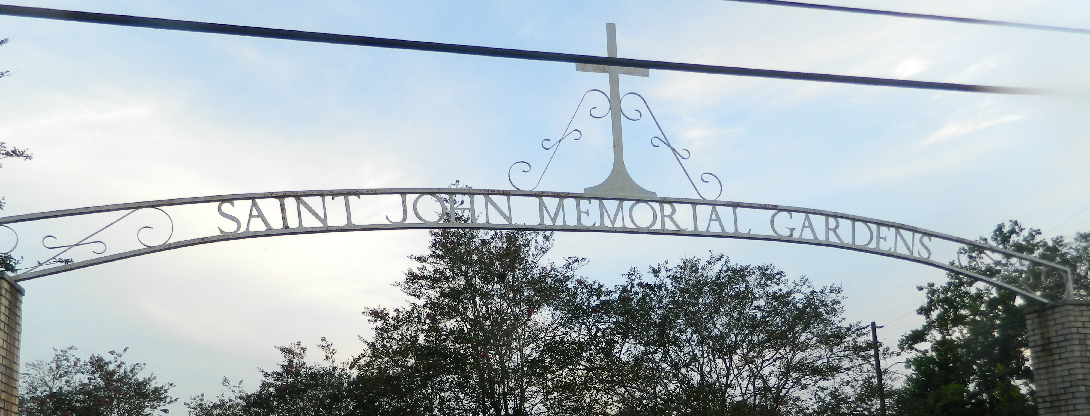

Bernadine J. "Bernie" Hall Brennecke, 70, a native of Kansas City, Mo., and resident of LaPlace for 22 years, died Feb. 21. She was the wife of Earl A. Brennecke and mother of Susan Landon and Robert, Carl and Larry Brennecke. She was also the daughter of the late Mack Sr. and Annabel Dick Hall and sister of Maxine Briscoe, Geraldine Richards and the late Mack Hall Jr. She is also survived by four grandchildren. She was preceded in death by one grandchild. Graveside services are today at 10 a.m. at St. John Memorial Gardens, LaPlace.

L'Observateur, LaPlace, Louisiana

Sunday, February 25, 2001

Contributed by Jane Edson