Daphannie Ann Brignac

May 14, 1981 – June 14, 2015

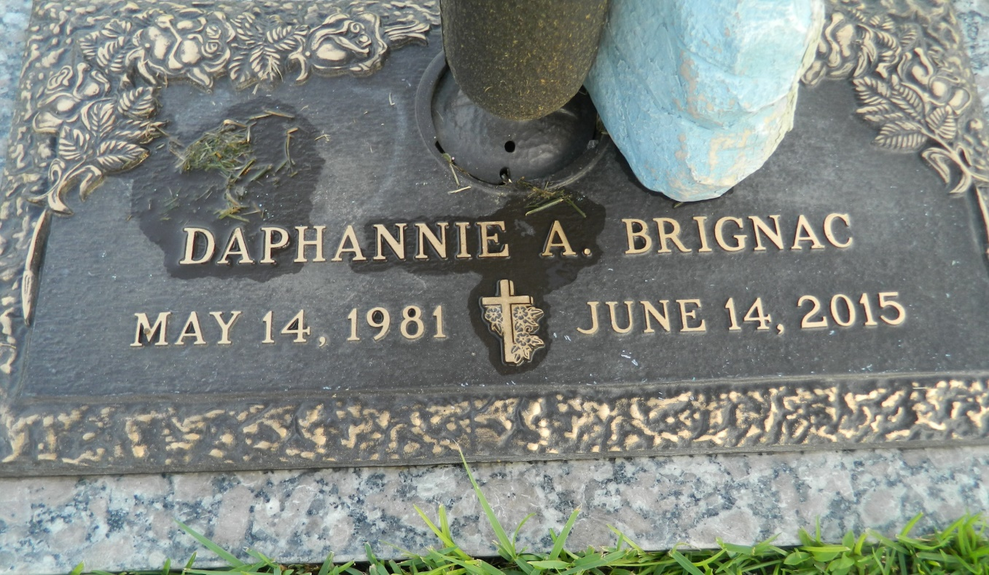

Daphannie Ann Brignac, 34, passed away at Baton Rouge General Medical Center on Sunday, June 14, 2015. Daphannie was a native of LaPlace and a resident of Ponchatoula. She was the beloved daughter of Terri D. Thibodeaux and the late Chris A. Brignac; sister of Zaine Thibodeaux; and granddaughter of Kernis Dugas Sr., Lorraine Landeche Dugas and the late Lawrence Brignac and Elaine Acosta. She was also survived by a host of aunts and uncles.

Relatives and friends are invited to attend the Funeral Mass at St. Joan of Arc Catholic Church, 529 W. 5th St. in LaPlace, on Wednesday, June 17 at 11 a.m. Visitation is at the church from 9 to 11 a.m. Interment is in St. John Memorial Gardens Cemetery. Arrangements are by Millet-Guidry Funeral Home. To view and sign the online guest book, visitwww.milletguidry.com.

L'Observateur, LaPlace, Louisiana

Tuesday, June 16, 2015

Contributed by Jane Edson