Lawrence J. Brignac

1924 – June 13, 2014

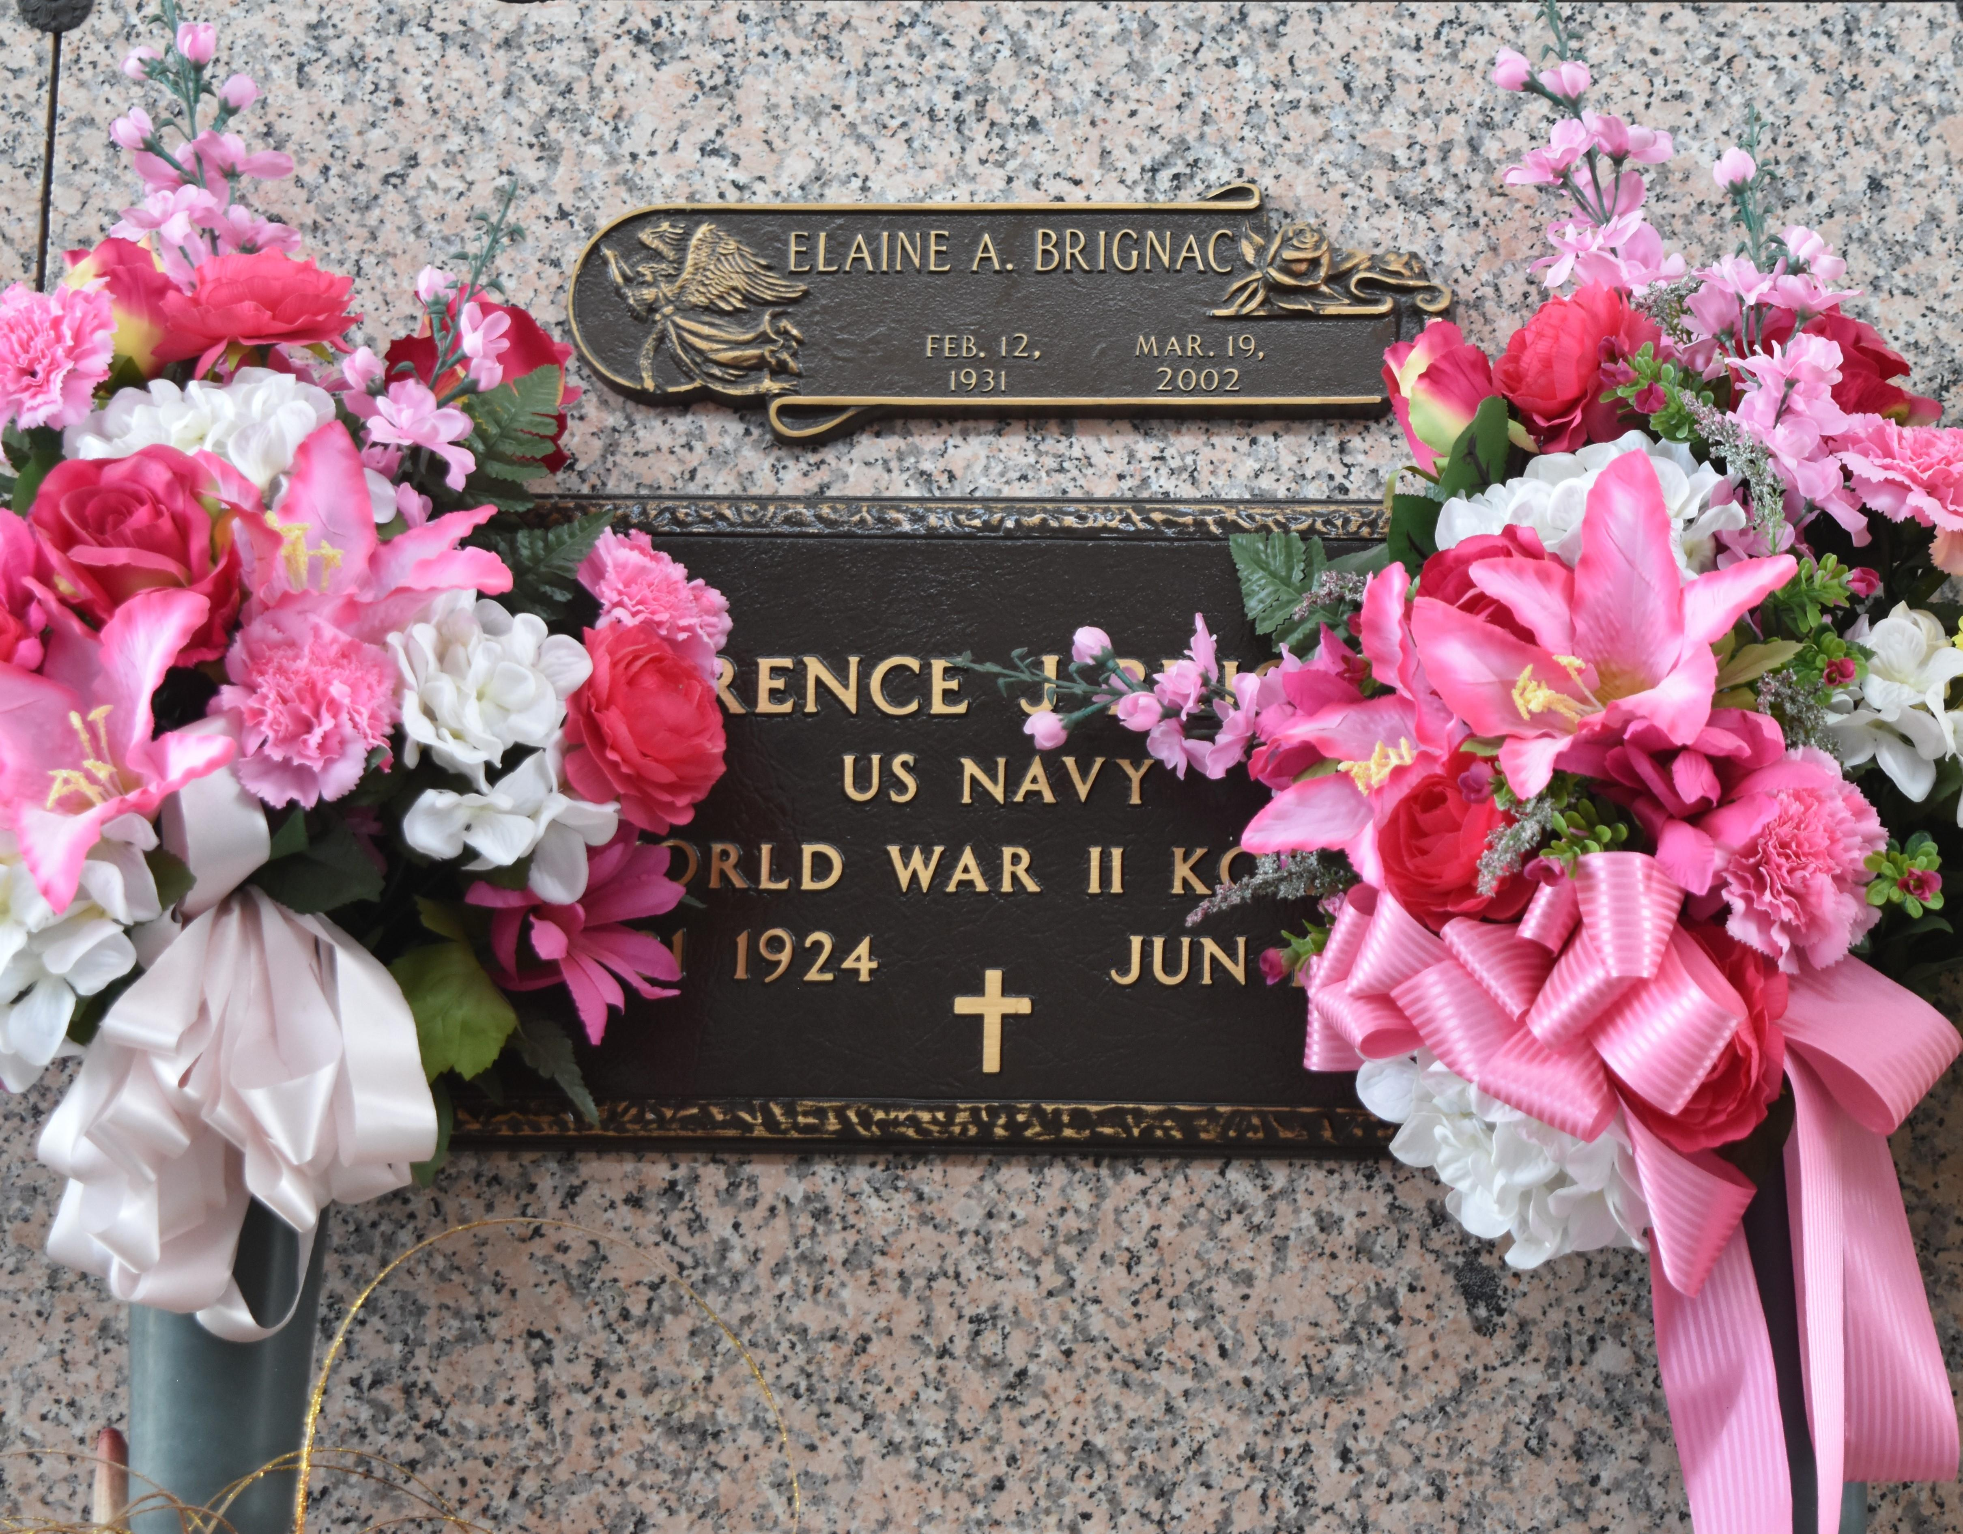

Lawrence J. Brignac, died on Friday, June 13, 2014. Beloved husband of the late Elaine Acosta Brignac. Father of Paulette Descant and the late Larry Sr. and Chris Brignac and Cathy Louque. Grandfather of Heath Brignac, Ronald Descant Jr., Kenny Norton, Mikki Brignac, Matt Brignac and Larry Brignac Jr.  
Son of the late Joseph and Martha Brignac. Brother of Marian Adams, Cecile Louque and the late Loretta Guidry, Russell, Antoine and Francis Brignac. He was a World War II Navy and Marine Corps Veteran. Age 89. A native of Gramercy and a resident of Garyville.  
 Relatives and friends are invited to attend services. Visitation at Millet-Guidry Funeral Home, 2806 W. Airline Hwy., LaPlace, LA, on Monday June 16, 2014, from 5:00 p.m. to 9:00 p.m. and on Tuesday from 8:00 a.m. to 10:00 a.m., followed by Mass in The Funeral Home Chapel at 10:00 a.m. Burial in St. John Memorial Gardens, LaPlace, LA.  
Special thanks to Cannon Hospice.  
  
The New Orleans Advocate (LA)

Jun. 14 to Jun. 17, 2014