Carol Ann (Kennair) Broussard

August 11, 1936 - May 22, 2024

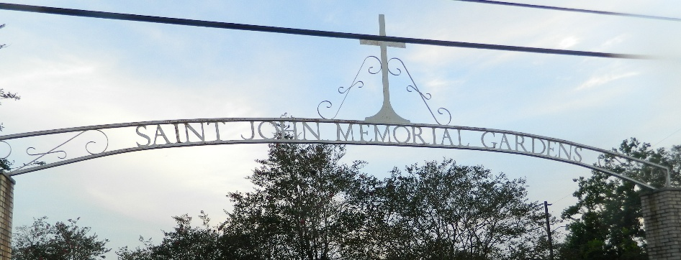

Carol Ann Kennair Broussard passed away on Wednesday, May 22, 2024 at the age of 87.
Beloved wife of Walter Broussard approaching 69 years. Loving mother of Kent Broussard (Cheryl) and Kirk Broussard. Grandmother of Lauren Broussard and Jennifer Boudoin (Rodney). Great-grandmother of Beau Boudoin. Daughter of the late Raymond Kennair and Stella Broussard Kennair. Sister of the late Raymond “Sonny” Kennair, Jr.
Carol loved spending time with her family, and she was always on the move. She especially loved shopping and was an avid animal owner and lover. Carol and Walter traveled the whole continental United States and abroad. She had a great passion for her job as a receptionist at Twin Oaks Nursing Home, stating she wishes she had never retired.
Relatives and Friends are invited to attend the Visitation and Funeral Mass at St. Joan of Arc Catholic Church, 529 W. 5th Street, LaPlace on Thursday, May 30, 2024. Visitation will be held at the Church from 9:00 a.m. to 11:00 a.m. followed by a Funeral Mass at 11:00 a.m. Interment in St. John Memorial Gardens Cemetery, LaPlace.

Millet-Guidry Funeral Home, LaPlace, Louisiana
May 24, 2024

