Earl Joseph Brown

November 2, 1940 – February 9, 2020

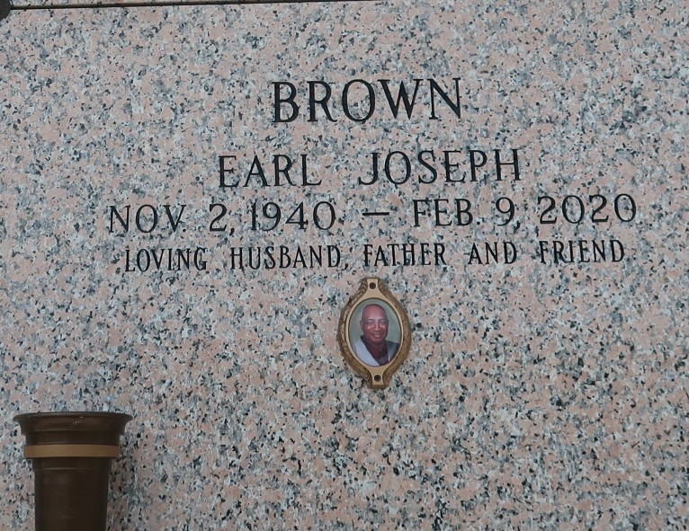

Earl J. Brown passed away on Sunday, February 9, 2020 at Ochsner Medical Center, Jefferson, LA. Son of the late Geneva Hymes and Edward Brown, Sr. Husband of Marion "Madeline" Brown (Meechie). Father of Danette, Paulette, Darryl, Lavette, Crystal, Constance and Dominique Brown, Timothy Mazique and Jayson Bardell. Brother of Edward Brown, Jr., Rosalie Lennix, Harold Brown, Lilton Brown, Beatrice Brown and Adam "Leroy" Shelton. Also survived by a host of grandchildren, great grandchildren, nieces, nephews, cousins, other relatives and friends. Age 79 years. A native and a resident of LaPlace, LA.

Relatives and friends of the family, also members of the surrounding congregations of Jehovah 's Witnesses are invited to attend the Discourse at The Kingdom Hall of Jehovah's Witnesses, 500 Colony Drive, LaPlace, LA on Saturday, February 15, 2020 at 10:00 a.m. Interment St. John Memorial Garden Cemetery, LaPlace, LA. Visitation at the above named Kingdom Hall from 9:00 a.m. until Service. SERVICED BY ROBOTTOM.

New Orleans Advocate, The (LA)

Thursday, February 13, 2020

Contributed by Jane Edson