Gregory Brown
February 17, 1959 – September 10, 2022

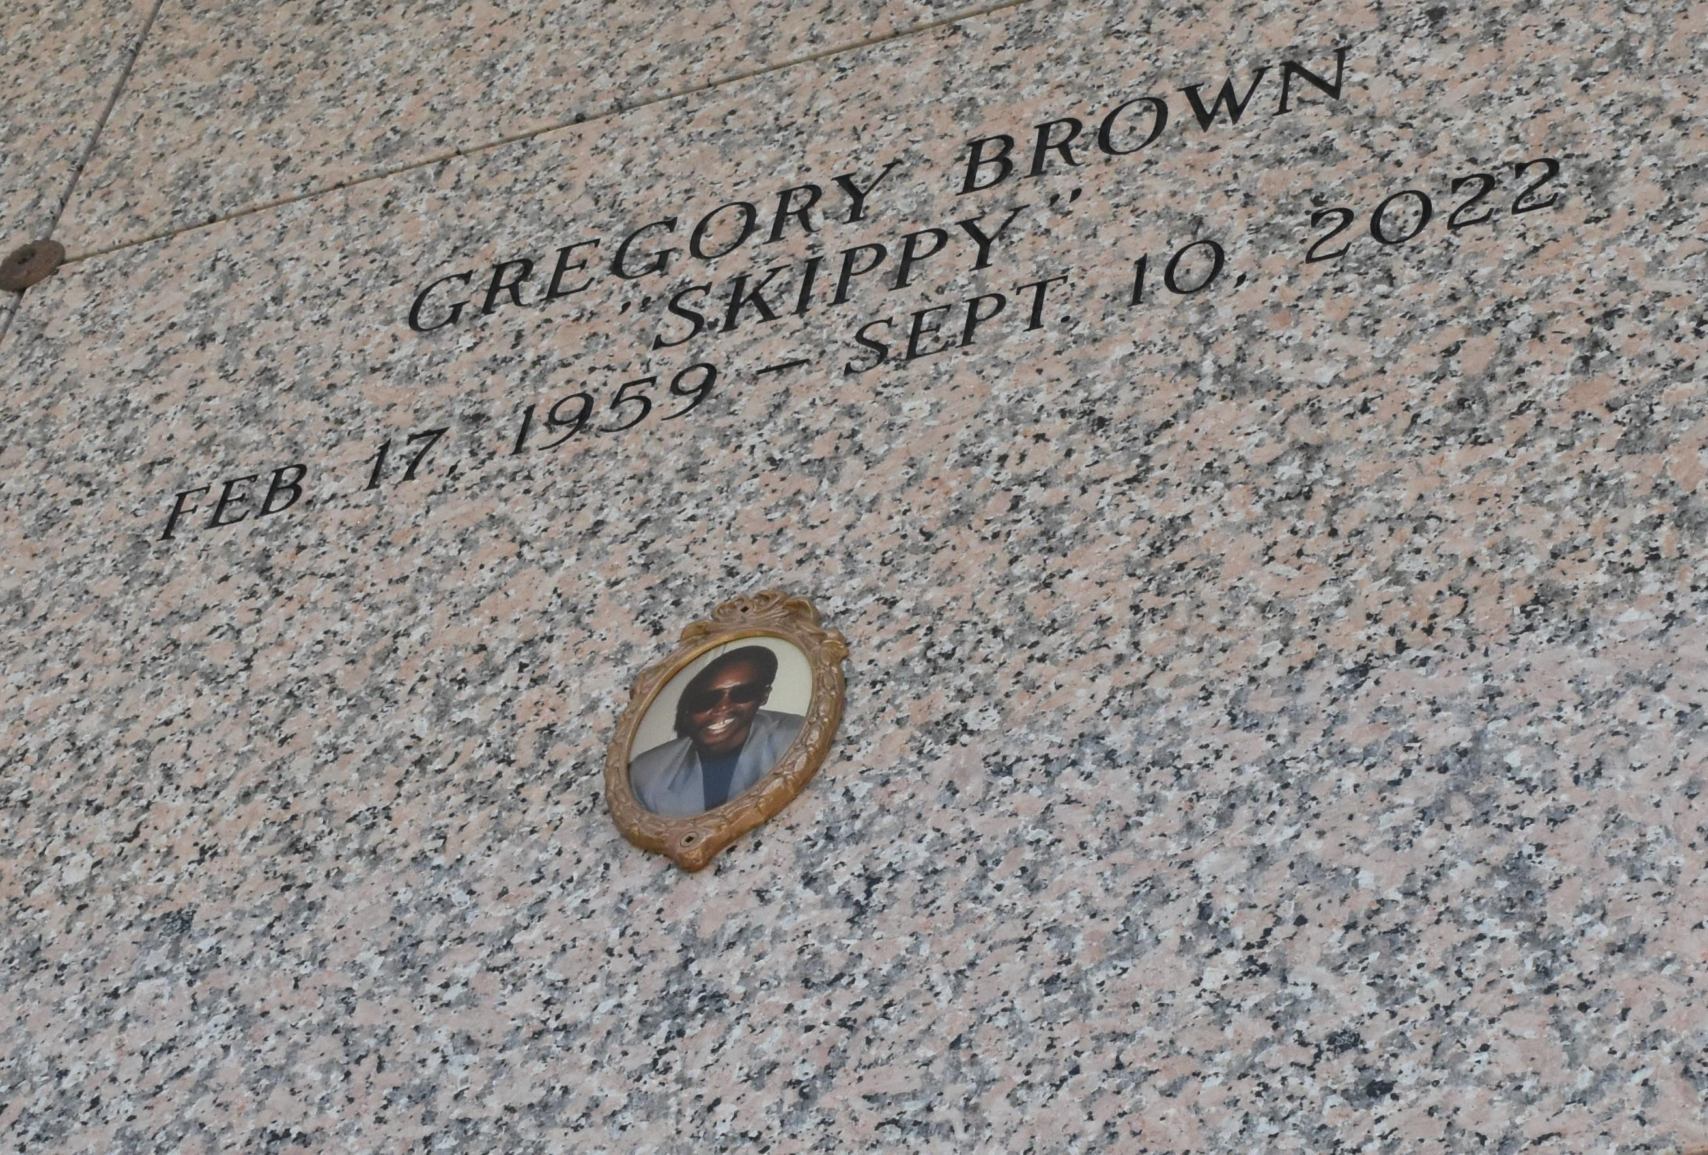

Gregory Brown "Skippy" died on Saturday, September 10, 2022 at his home in New Orleans, LA. Son of Anna Bell Brown and Altis Brown, Sr. Father of Leana Smith and Gregory Lane. Brother of Cornell Brown, Cynthia Brown, Altis Brown, Jr. (Loretta), Sandra Vinnett (Edward, Sr.), Veronica Brown, Valerie Brown, Wanda Burks (Ivory), Paula Leon and Reginald Lawrence. Also survived by 7 grandchildren and a host of aunts, uncles, nieces, nephews, cousins, other relatives and friends. Age 63 years. A native and a resident of Norco, LA. Gregory was a member and usher of Greater Good Hope Baptist Church.
Relatives and friends of the family also pastors, officers and members of Greater Good Hope Baptist Church and all neighboring churches are invited to attend a funeral service at Greater Good Hope Baptist Church, 47 Cathy Street, Norco, LA on Saturday, September 17, 2022 at 12:00 noon. Rev. Tyrone Scott, Pastor, officiating. Visitation at the above-named church from 10:00 am until service time. Interment St. John Memorial Garden Cemetery, LaPlace, LA. In accordance with CDC guidelines for COVID-19, masks are suggested for everyone in attendance. Service by Robottom.

The Times-Picayune, New Orleans, Louisiana
Sep. 16, 2022

