Walter George Brown
January 16, 1929 – September 3, 2014

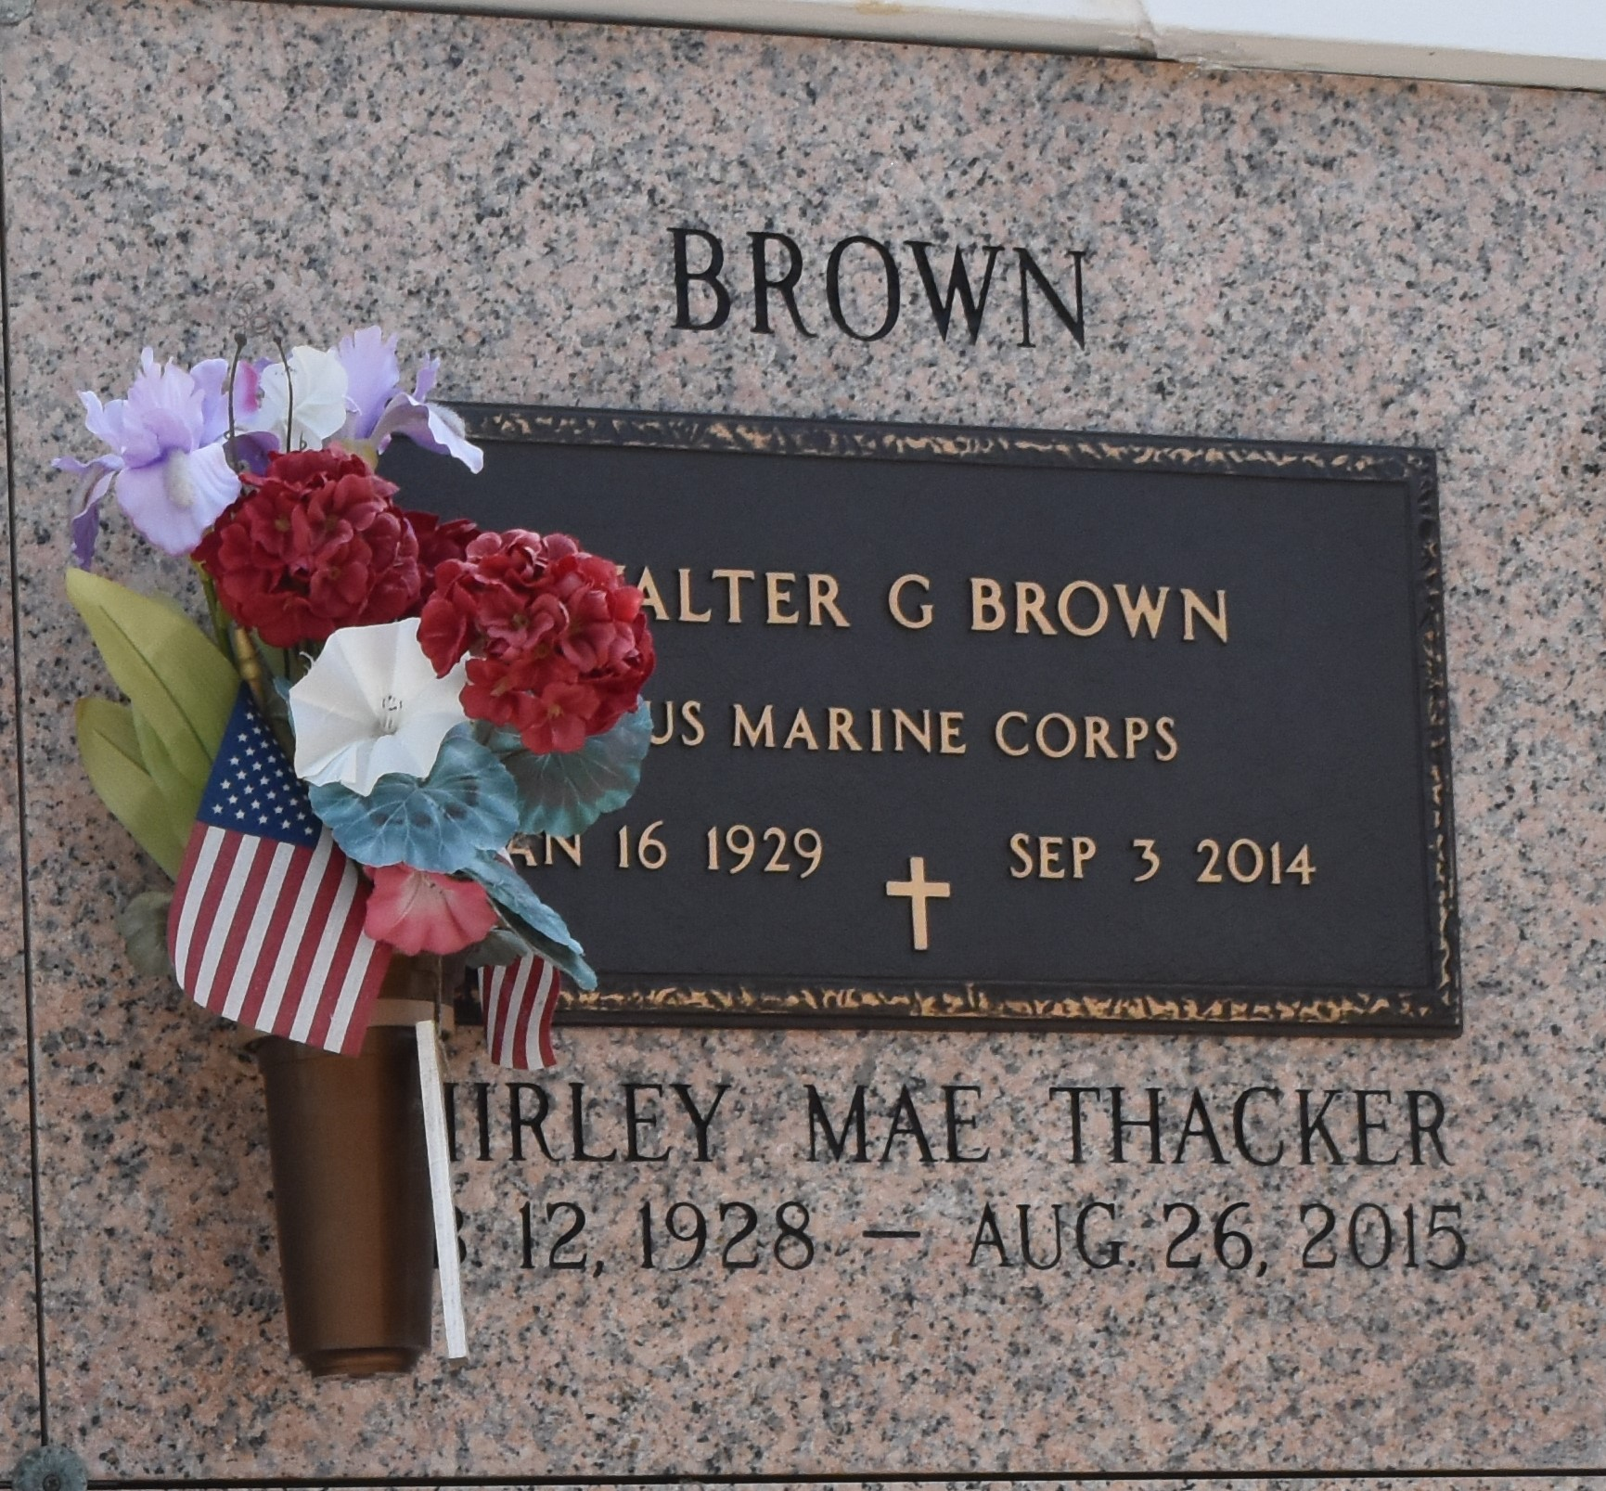

Walter G. Brown died on Wednesday September 3, 2014. Beloved husband of Shirley Thacker Brown for 65 yrs. Father of Pamela Brown, Sherry Brown Thompson and George Brown. Grandfather of Derrik Brown. Son of the late Paul and Leone Brown. Brother of the late Floyd Brown Jr. He retired from Delta Airlines after 36 yrs. and traveled 50 states, 21 foreign countries and 12 trips to Hawaii with his wife. He was a WWII Marine Corp. Veteran. He walked with his Lord daily. Age 85. A native of Indiana and a resident of LaPlace, LA. Relatives and friends are invited to attend services. Visitation at the First United Methodist Church, 301 Bamboo Rd., LaPlace, LA on Monday September 8, 2014 from 9:00am to 11:00am, followed by Services at 11:00am. Burial in St. John Memorial Gardens Cemetery, LaPlace, LA. Arrangements by Millet-Guidry Funeral Home, LaPlace, LA.
The Times-Picayune, New Orleans, Louisiana
Sep. 5 to Sep. 7, 2014

