Theresa (Carlisi) Bull

April 7, 1923 – April 14, 2006

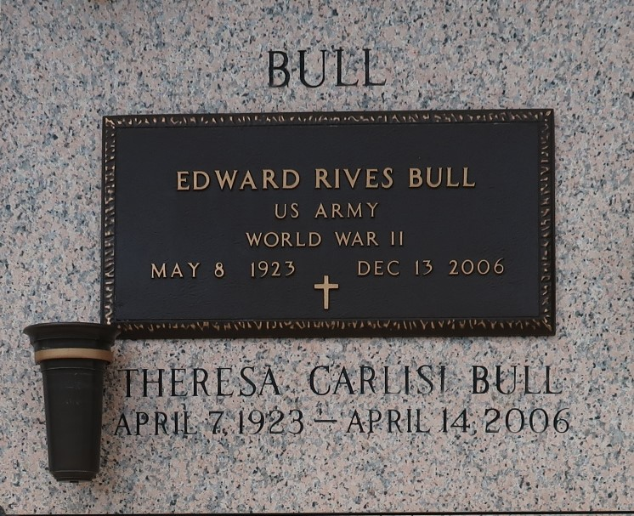

Theresa Carlisi Bull of LaPlace, LA on Friday, April 14, 2006. Homemaker and Co-owner of the former Galvez Pharmacy in New Orleans. Beloved wife for 55 years of Edward Rives Bull. Loving mother and mother-in-law of John Edward and Kathy L. Bull of Kenner, Rene Charles and Mary Ann P. Bull of Birmingham, Alabama, Andrew and Helena Bull Cupit of LaPlace, James Roy Bull of Metairie, and Patrick Joseph Bull and Petrina P. Bull of Slidell. Adored grandmother of Jessica Bull, Trevor L., Matthew A., Besse B. Richey, Danielle B. Bowling, Scott Bull, Andy Cupit, James Cupit, Kelly Cupit, Angelle Cupit, Marie Cupit, Paul Cupit, Julia Cupit and Mira Bull. Greatgrandmother of Amelia Besse Richey. Daughter of the late Sigismondo Carlisi and Lena Oddo Carlisi. Sister of John Carlisi of Three Rivers, Michigan, Laura C. Tambrallo of Kenner and the late Manuel Carlisi, Antoinette C. Russo, Salvador Carlisi, and Lucas Carlisi. Also survived by a host of nieces, and nephews. Member of Gabblers social group of Arabi for 40 years. Past parishioner of St. Mary of the Angels in New Orleans and St. Robert Bellarmine in Arabi and current parishioner of St. Joan of Arc in Laplace. Special thanks to River Region Hospice. Age 83 years, a native of New Orleans, former resident of Arabi for 40 yrs. and a resident of LaPlace, LA for the past 3 years. Relatives and friends of the family are invited to attend services. Visitation at St. Joan of Arc Catholic Church, 529 W. 5th, LaPlace, La on Mon. Apr. 17, 2006 from 9 am to 11 am followed by religious services at the church at 11 am. Burial in St. John Memorial Gardens Cemetery, LaPlace, LA. In lieu of flowers masses preferred. Arrangements by Millet-Guidry Funeral Home, LaPlace, LA.

Times-Picayune, The (New Orleans, LA)

Sunday, April 16, 2006

Contributed by Jane Edson