Doris (Tassin) Burl

March 2, 1936 – March 13, 1999

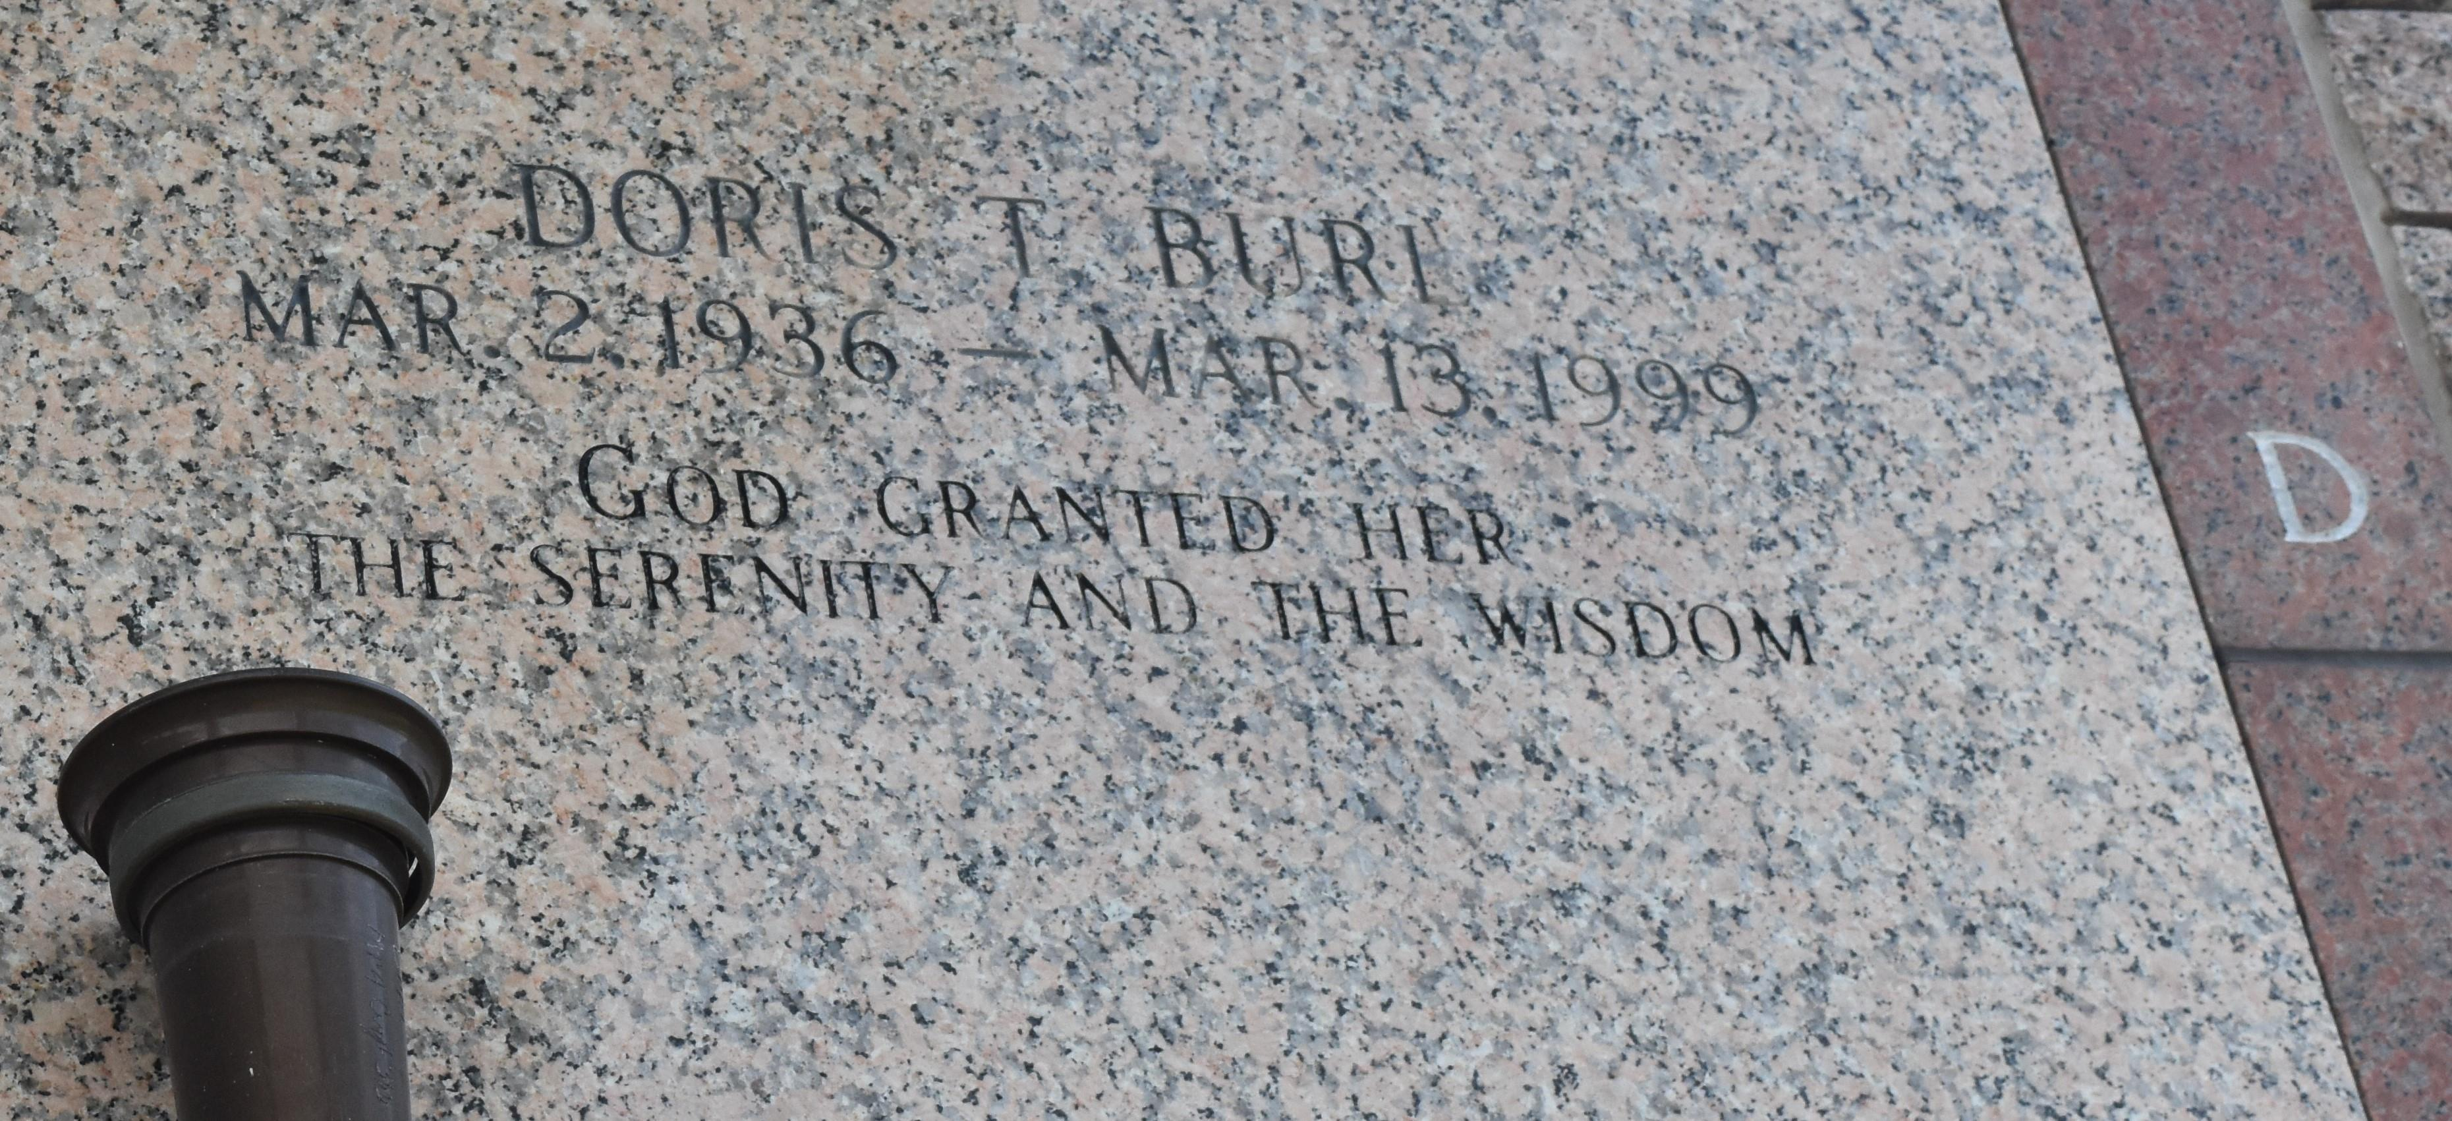

Doris Tassin Burl, a retired lab technician for Dupont-Dow, died Saturday of complications from a stroke at her daughter's home. She was 63. Mrs. Burl was born in New Orleans and lived in Mount Airy for the past 32 years. She attended Southern University.

Survivors include a son, Andre Burl Sr.; a daughter, Samantha B. Wilson; four stepdaughters, Sonya, Debra, Veronica and Rachel Burl; a sister, Ida Mae Tassin; and five grandchildren.

A funeral will be held Saturday at 11 A.M. at First Community Antioch Baptist Church in Paulina. Burial will be in St. John Memorial Gardens. Hobson-Brown Funeral Home is in charge of arrangements.

Times Picayune, New Orleans, Louisiana

Friday, March 19, 1999