Barbara (Snyder) Burton

August 29, 1941 – October 9, 2021

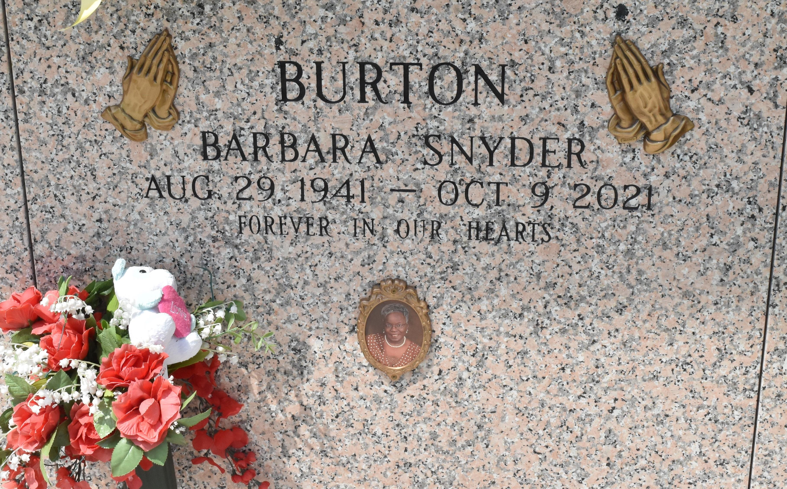

Barbara Ann Snyder-Burton peacefully departed this earthly life and entered into eternal rest at the age of 80 on October 9, 2021. Daughter of the late Rev. Peter Snyder, Sr. and Irene (Pauline) Snyder. Mother of Ilana Burton-Nealond and Delano Burton. Sister of Larry Snyder, Sr. She is survived by 7 grandchildren, 6 great grandchildren, nieces, nephews, cousins, other relatives and friends.

A Celebration of Life will take place on Saturday, October 23, 2021 at Bethlehem Baptist Church, 146 E 20th St., Reserve, LA at 11:00 a.m. Rev. Dr. Forell Bering, Sr. officiating. Viewing from 9:00 a.m. until service time ONLY. Mask and Social Distancing are required. Services entrusted to the professional staff at Hobson Brown Funeral Home, 134 Daisy St., Garyville, LA 70051.

The Times-Picayune, New Orleans, Louisiana

Oct. 21 to Oct. 23, 2021

Contributed by Jane Edson