Richard Butler

April 22, 1938 – October 2, 1998

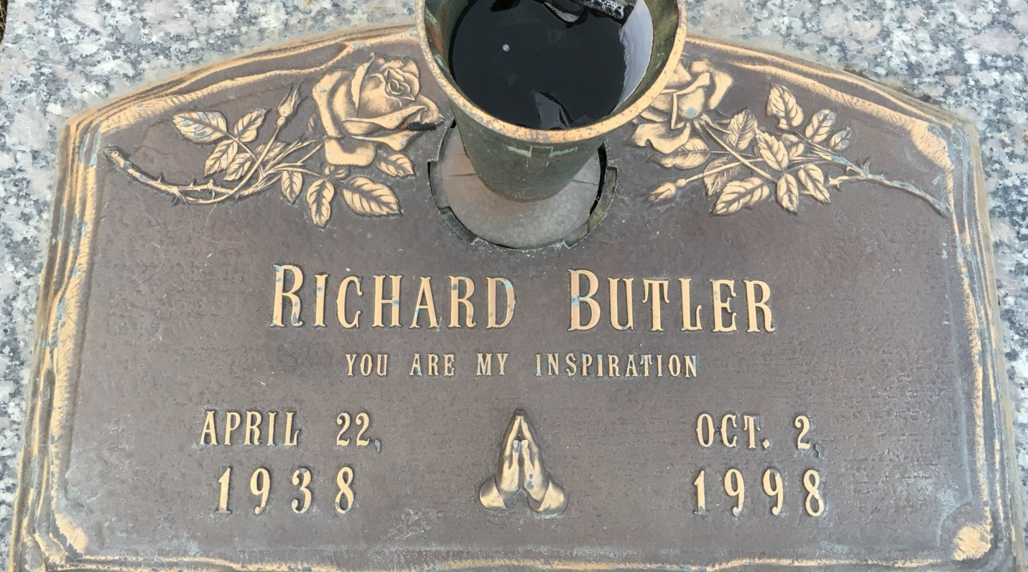

Photo by Team T-Lo

Richard Butler, a retired St. John the Baptist Parish teacher, died Oct. 2 of cirrhosis of the liver at Ascension Hospital. He was 60. Mr. Butler was born in St. Francisville and lived in Reserve for the past 33 years. He taught Driver's Education and Agriculture at Fifth Ward, Sixth Ward, Leon Godchaux and East St. John High Schools. Survivors include his wife, Bobbie Betts Butler, a son, Richard Butler of Columbia, Mo.; a daughter, Toni Butler of Laplace; his mother, Nellie Butler of Baton Rouge; two sisters, Annie Williams and Willie Mae King; and a grandchild. A funeral will be held today at 10 A.M. at Our Lady of Grace School gymnasium in Reserve. Burial will be in St. John Memorial Garden in Laplace. Earl Baloney and Sons Mortuary is in charge of arrangements.

Times Picayune, New Orleans, LA

October 10, 1998