JoAnn (Joseph) Byers - Cooper

## December 21, 1957 – March 10, 2023

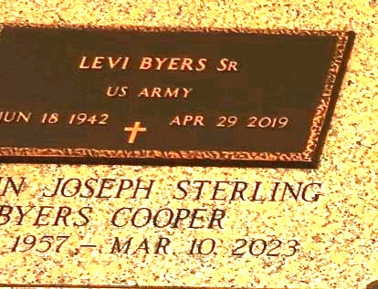

Deaconess JoAnn Cooper was born on December 21, 1957, in New Orleans, La., to the late Etienne Sr and Sallie Ann Joseph. JoAnn Cooper grew up in Reserve La with her six siblings. She accepted Christ as her savior and was baptized in 1961 by the late Pastor Henry Robinson of the Mt. Zion Baptist Church #1 in Garyville, LA.

After Graduating from Leon Godchaux High School in Reserve, LA in 1975, JoAnn attended Meadows Draughon Business College in New Orleans, LA where she received her Business Degree in March of 1977.

In 1978 she married Harold Sterling Sr. and from this union she was blessed with her first-born Candace Sterling. In 1989, JoAnn was married to Levi Byers Sr. From this union they had two children Levi Jr and Jolethia Byers and JoAnn's bonus children, John and Shirley Byers.

On December 21, 2020, she married Adam Cooper, and gained 7 bonus children from this union. JoAnn was employed with the St John the Baptist Parish School system for 28 years as a manager over the cafeteria

employees and retired in 2019.

JoAnn Loved the Lord and was truly a servant of the Lord. Her favorite Scripture was 2 Chronicles 7:14. Joann joined the Deaconess Board on February 15, 2007, in which she served faithfully until her departure.

JoAnn leaves to cherish her loving memories her devoted husband, Adam Cooper Sr. of Gramercy, LA; children, Candace Sterling of Reserve, LA, Levi (Rachel) Byers Jr. of Laplace LA, and Jolethia Byers (James) of Metairie, LA; bonus children, John and Shirley Byers of Marrero, LA, and Lytressa (Jamal) Lambert of Laplace, LA; grandchildren, Da’Jon (Elisia), Ka’Jia Taylor, Da’Jia and La’Cai Sterling, Kejuan Fobb, Za’nai , Levi III and Za’kirah Byers , Jadesola Babalola, Sarah Kennedy, and Myshell and Tre Nelson; great-grandchildren, Dior Taylor, Riko and Ryli LaCroix; siblings, Emma Gomez of Reserve, LA, Sallie Mae (Gaylen) Lightell of Reserve, LA, Pastor Edgar (Linda) Joseph of Avondale LA, Etienne Jr. (Gwendolyn) Joseph of Grand Prairie, Tx and Michael (Lesa) Joseph of Fort Worth, Tx; Godchildren, Cantrell Keller, Tayna Nicholson, Vernon Jr., Jerry Singleton Jr. and Winter Smith; and a host of nieces, nephews, other relatives and friends.

On March 10, 2023, JoAnn went home to be with the Lord. She was preceded in death by her parents, husband Levi Byers Sr., one brother, Alfred Joseph, and brother-in-law, Irvin Gomez.

A celebration of life honoring JoAnn Cooper will be held on Saturday, March 25, 2023, at Mt. Zion Baptist Church #1, 144 Litttle Hope St., Garyville, LA 70051. Visiting period with family will begin at 10am. There will be NO VIEWING OF THE BODY. Services will begin at 11am. Entombment to follow at St. John Memorial Gardens, 2205 W. Airline Hwy., Laplace, LA 70068. Final care and professional services entrusted to Treasures of Life Funeral Services, 315 E. Airline Hwy., 315 E. Airline Hwy., Gramercy, LA 70052.

Treasures of Life Funeral Services, Gramercy, Louisiana