Levi Byers Sr.

June 18, 1942 – April 29, 2019

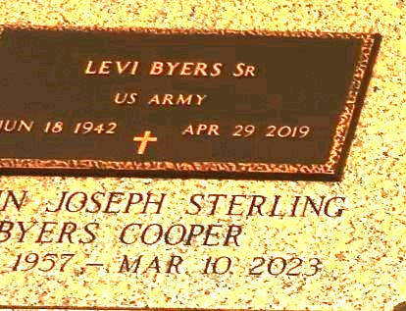

Deacon Levi Byers Sr.was born June 18, 1942, to the late Lucille & Lawrence Byers in Berwick, LA. He served in the United States Army for 4 years. Levi Byers married Joann Joseph on July 8, 1989. He was blessed with 4 children. John Byers (Amy) of New Orleans, LA, Shirley Byers of New Orleans, LA, Levi Byers, Jr (Rachel) of Laplace, LA and Jolethia Byers of Kenner, LA, one devoted stepdaughter, Candace Sterling and 20 grandchildren.

Over the years I have known Deacon Byers as a good servant. Deacon Byers was baptized by the Late Rev. Dr. Henry Robinson in the year of 1991. The scriptures say, "the steps of a good man are ordered by the Lord". He carried the duties of a deacon as Paul listed in the Bible (1 Timothy 3). First, a deacon must be a man of dignity, Second, a deacon must not be double-tongued, Third, a deacon must not be addicted to much wine, Fourth, a deacon must not be fond of sordid gain, Fifth, a deacon must hold to the mystery of the faith with a clear conscience, Sixth, a deacon must first be tested and found to be above reproach. Deacon Byers was outspoken and would let you know how he felt about any situation. He was a servant who loved the Lord and loved doing work for the church. He later became appointed chairman of the deacon board, served as church treasurer, Sunday School Teacher and Vacation Bible School Teacher.

He leaves to cherish his memories; his wife Joann Joseph Byers, children, John Byers, Shirley Byers, Levi Byers, Jr, Jolethia Byers, stepdaughter Candace Sterling, 20 grandchildren, godchildren Jerry Singleton, Jr., Charlitta Naverro, devoted friend Michael Cooks, devoted Brother & Sister-in-law Gaylon & Sally Joseph Lightell. His was preceded in death by his parents, his siblings; sister, Edna Byers, two brothers, Andrew Byers, Sr., and Clarence Byers. One sister-in-law Viola Byers.

Treasures of Life Funeral Services, Gramercy, Louisiana