Willie Mae (Coburn) Byrd

July 11, 1925 – December 5, 2005

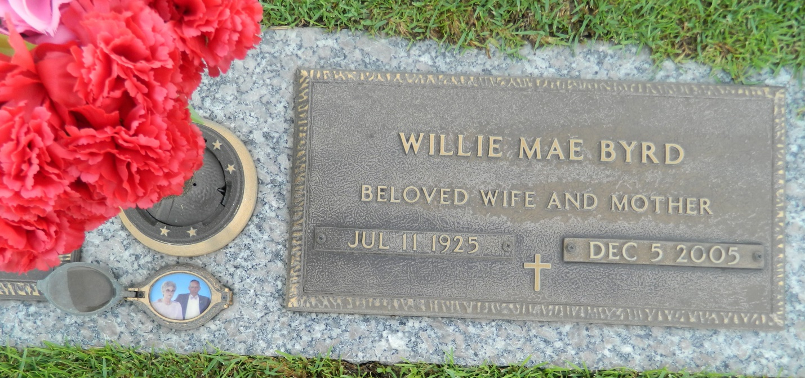

Willie Mae Coburn Byrd on Monday, December 5, 2005 at 11:40 p.m. Wife of the late Willie “Bill” Byrd. Mother of Evelyn Ruth Worley, Larry Wayne Byrd and Carolyn Faye Bickford. Daughter of the late Eva Alice Cavaness and George Frank Coburn. Sister of Helen McGee, Alice Lombas and the late Lula Rogers, Burley, Eva, Cecile and Georgia Mae Coburn. Also survived by 6 grandchildren and 5 great-grandchildren. Aged 80 years, a native of Melville, LA, a resident of Kenner for 30 years, and a resident of St. Rose, LA for the past 13 years.  
  
Relatives and friends of the family are invited to attend the funeral. Services from the Kenner Funeral Home of L. A. Muhleisen and Son, 2607 Williams Blvd. on Thursday, December 8, 2005 at 12:00 noon. Interment in St. John Memorial Gardens, LaPlace, LA. Visitation after 10:00 a.m. on Thursday.

Times-Picayune, The (New Orleans, LA)

Wednesday, December 7, 2005

Contributed by Jane Edson