Bobbie Doris (Koen) Cain
November 28, 1924 – February 20, 2001

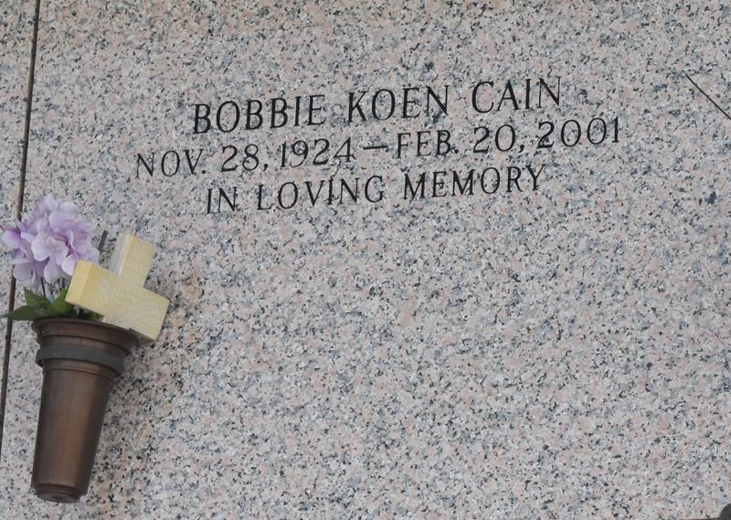

Bobbie Koen Cain, 76

A resident of LaPlace for five years, she died Tuesday, Feb. 20, 2001. She was 76 and a native of Leesville. She was the beloved wife of the late Eloise Cain; mother of Clyde Cain, Patsy Williams, Sharon Cain, Linda Cain and Betty Bossier; sister of Dorothy Figueroa, and preceded in death by nine brothers and sisters. Survived by 20 grandchildren and 26 great-grandchildren.

Relatives and friends of the family are invited to attend the funeral services at Millet-Guidry Funeral Home, 2806 W. Airline Highway, LaPlace, Friday, Feb. 23, 2001, followed by religious services in the funeral home chapel at 2 p.m. Burial in St. John Memorial Gardens Cemetery, LaPlace. Visitation from noon on Friday until services.

Advocate, The (Baton Rouge, LA) - Thursday, February 22, 2001
Contributed by Jane Edson

