Jack Norman Cali, II

October 7, 1950 - November 6, 2019

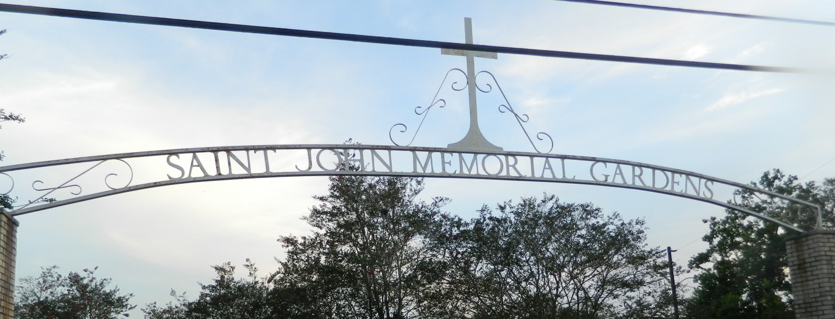

Jack Norman Cali, II entered peacefully into Heaven on Wednesday, November 6, 2019 at the age of 69. He was born on October 7, 1950 and was a native and lifelong resident of LaPlace.  
 He devoted 40 years as a heavy equipment operator at the Shell Refinery in Norco. Jack enjoyed riding his motorcycle and working on transmissions in his garage.

Former husband of the late Sheryl Shook. Jack is survived by his longtime companion and fiancée, Dolores Marks. Beloved father of Jack Cali, III (Cristy), Jennifer Cali-Jones (Taylor), Jessica Cali-Domiano (Neno) and Ashlynn Duhe (Stevie). Stepfather of Kelly Cambre and Shane Cambre. Grandfather of Alex and Madi Ferguson, Madeline Cambre, Molly Welch, Dominik Messina, Pheeby Guedry, Raymond Jack, Cali Borne, Stevie-Lynn Duhe and Steven Duhe, III. Brother of Norma Schexnayder (Delbert). Godfather of Christopher Menard. Also survived by nieces, nephews, numerous cousins, dear friends and co-workers.  
 Jack was preceded in death by his parents Lucille Bienvenu and Norman Cali; stepdaughter, Angie Cambre.  
 The family would like to thank the staff of Egan Healthcare and Hospice for their assistance during this difficult time.  
 Relatives and friends are invited to attend the visitation at St. Joan of Arc Catholic Church, 529 W. 5th Street, LaPlace on Tuesday, November 12, 2019 from 9:30 a.m. until 11:30 a.m. followed by a Funeral Mass at 11:30 a.m. Interment in St. John Memorial Gardens Cemetery.

Millet-Guidry Funeral Home, LaPlace, LA

November 11, 2019