Cynthia (Perilloux) Cambre
April 6, 1942 - January 6, 2024

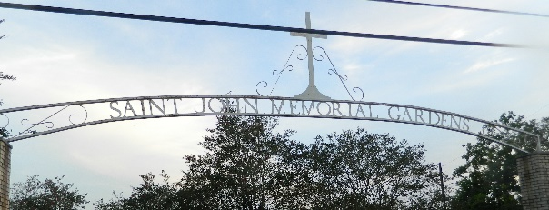

Cynthia Perilloux Cambre passed away at her residence on Saturday, January 6, 2024 at the age of 81. She was a native and lifelong resident of LaPlace, LA. Cynthia was a retired schoolteacher from St. John Parish School System. Cynthia also coached cabbage ball teams at LaRayo Recreation Center in LaPlace. Cynthia was an avid fan of Cubs Baseball, Saints, LSU, St. Charles High School Comets Football and all sports in general. When she wasn’t watching sports she enjoyed game shows and soap operas. She also enjoyed spending time with her grandchildren and great grandchildren.
Cynthia was the beloved wife of the late Donald “Dos Gris” J. Cambre. Loving mother of Drake Anthony Cambre (Wanda), Malese C. Orgeron (Ray) and Cleve Cambre. Grandmother of Kristine Troxclair (Timothy), Kayla Bissel (Jacob), Damian Orgeron (Kara), Devin Orgeron and Megan Orgeron. Great grandmother of Hudson Troxclair and William “Willie” Orgeron. Daughter of the late Cleveland Perilloux and Eva Roussel Perilloux. Preceded in death by her siblings, Cleveland “Junior” Perilloux, Jr., Alan Perilloux, Joyce Perilloux Millet and Wayne Perilloux. She is also survived by several nieces, nephews and cousins.
The family wishes to thank Modern Home Health and Hospice for the loving care that they gave to Cynthia during her last days. The nurses and aides were a godsend in making Cynthia's passing a comfortable one.
Relatives and friends are invited to attend a Funeral Service at 12:00 PM on Thursday, January 11, 2024 at Millet-Guidry Funeral Home, 2806 W. Airline Hwy, LaPlace, LA 70068. Visitation will begin at 9:30 AM. Interment will be in St. John Memorial Gardens Cemetery in LaPlace, LA.

Millet-Guidry Funeral Home, LaPlace, Louisiana
January 10, 2024

