Helen (Hebert) Cambre

June 2, 1939 – February 2, 2009

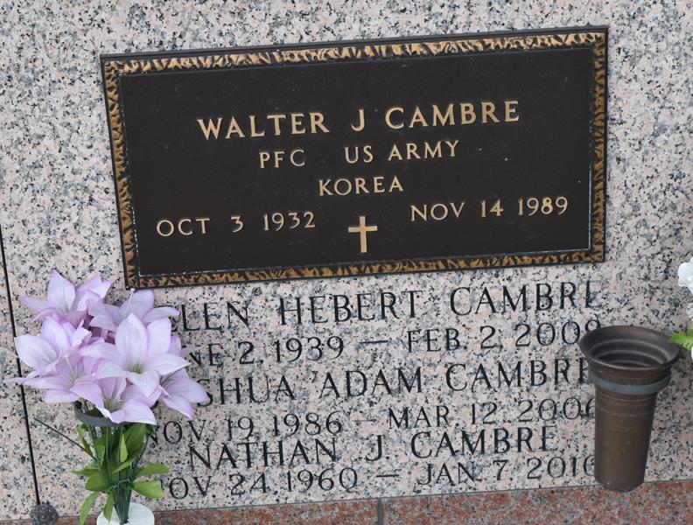

Helen Hebert Cambre on Monday, February 2, 2009 at 10:37am. Beloved wife of the late Walter (Whitey) Cambre, Sr. Mother of Walter, Jr. and wife Daina Cambre, Nathan Cambre, Doreen and husband Kirk Jouty, Sr., Kenneth and Travis Cambre. Also survived by 6 grandchildren, 1 deceased and 13 great-grandchildren. Preceded in death by 3 brothers and 1 sister. Age 69 years. A native and resident of LaPlace, La.

Relatives and friends are invited to attend services. Visitation at Millet-Guidry Funeral Home, 2806 W. Airline Hwy, LaPlace, La., on Tuesday, February 3, 2009 from 5:00pm to 8:00pm and on Wednesday from 8:00am to 9:45am. Followed by Religious Services at St. Joan Of Arc Catholic Church, LaPlace at 10:00am. Burial in St. John Memorial Gardens Cemetery, LaPlace.

The Times-Picayune, New Orleans, Louisiana

February 3, 2009