Septima (Weber) Cambre

March 17, 1918 – January 6, 2007

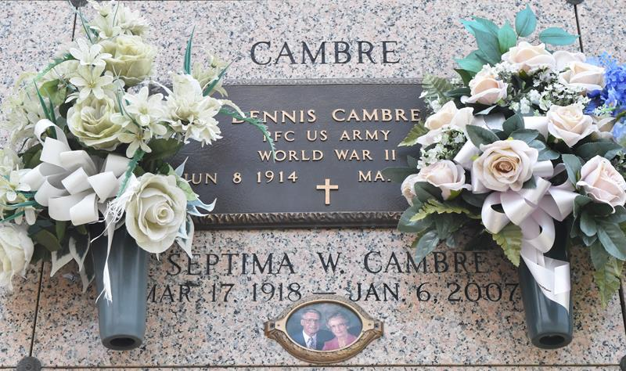

Septim (Sep) Weber Cambre on Saturday, January 6, 2007 at 5:05 PM. Beloved wife of the late Dennis Cambre. Mother of June Cambre Matherne and the late Dennis Cambre, Jr. Mother-in-law of Phil Matherne and Susan Weber Cambre. Grandmother of Elizabeth C. Brady, Angela Cambre, Tropy, Todd and Phil Matherne, Jr. Also survived by 11 great grandchildren. Age 88 years. A resident of Laplace, LA.

Relatives and friends of the family, also Laplace Fire Dept. Ladies Auxillary, St. Joan of Arc Altar Society, River Parishes Hospital Volunteers are invited to attend services. Visitation at Millet-Guidry Funeral Home, 2806 W. Airline Hwy., Laplace, LA. on Tuesday, January 9, 2007 from 9AM until 11AM. Followed by Religious Services at the Funeral Home Chapel at 11AM. Burial in St. John Memorial Gardens, Laplace, LA.

The Times-Picayune, New Orleans, Louisiana

January 8, 2007