William Jennings Cambre, Sr.
December 29, 1913 – May 12, 2002

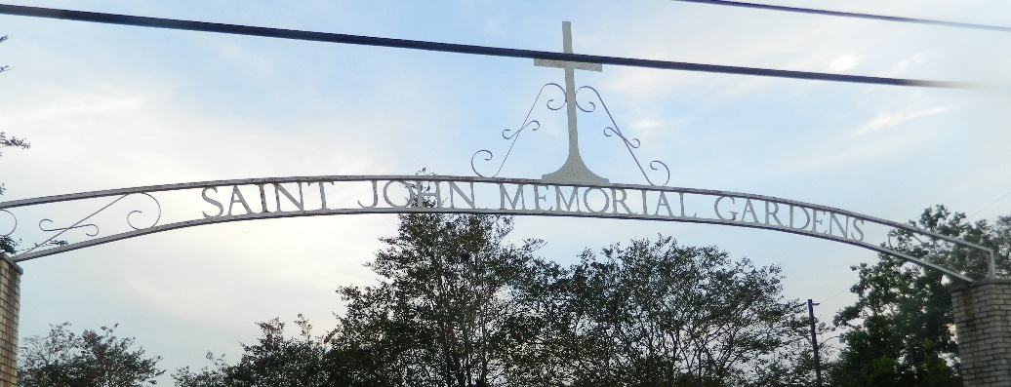

William Jennings Cambre, On Sunday May 12, 2002 At 6:02 Pm. Beloved Husband Of The Late Beulah Clement Cambre. Father Of Mary Carol Cambre Oncale, William J, Cambre, Jr., Donna Cambre Chauvin, And Donald Cambre. Brother Of Lucille Cambre Duhe And The Late Francois E. Cambre, Louis A. 'Toot' Cambre. Son Of The Late Francois And Marie Lasseigne Cambre. Also Survived By 3 Grandchildren And 2 Great Grandchildren.
A Retired Machinist From Kaiser Aluminum, Staff Sgt. In The U.S. Army And Served In Company ' B' 774 Tank Battalion. Awarded The Good Conduct Medal.
His Love Of Music Prompted Him To Form A Jazz Band In The 1940's That Entertained Many Area Residents. Age 88 Years, A Native Of Reserve, La. And A Resident Of Laplace, La. For The Past 52 Years.
Relatives And Friends Of The Family Are Invited To Attend Services. Visitation At St. Joan Of Arc Catholic Church, 529 West Fifth Street Laplace, La. On Tuesday May 14, 2002 From 9 Am Followed By Religious Services At 11 Am. Burial In St. John Memorial Gardens, Laplace, La.
Times Picayune, New Orleans, Louisiana
May 14, 2002

