Janie (Dennis) Campbell

December 10, 1921 – July 17, 2017

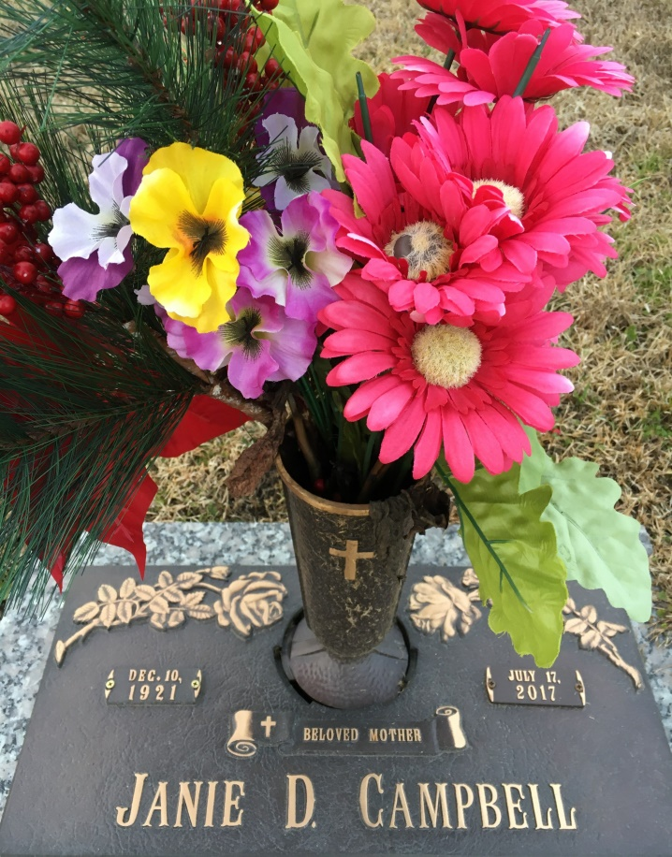

Photo by Team T Lo

Janie "Grammoe" Dennis Campbell, a native of Norco, LA and a resident of LaPlace, LA, departed this earthly life on Monday July 19, 2017 in her home at the age of 95 yrs.   
Janie was the wife of the late Albert (Ahbear) Campbell and beloved daughter of the late James and Charlotte Dennis. Janie was the mother of 9 children, 5 boys and 4 girls: Albert, Larry, Anthony, Ronald and Troy Campbell, Robin Franklin, the late Grace Watkins, Mary Hollins, and Barbra Anthony.   
 Janie was one of 11 children, 2 remain living Charlotte Dennis and Corey Lee Mitchell. Janie has over 350 grand, great grand and great, great great grandchildren, three God children and a host of nieces, nephews, other relatives and friends.  
 Pastors, Officers and Members of Mount Calvary Baptist Church and all neighboring churches are invited to attend her home going celebration on Saturday July 22, 2017 at 11:00 am at Mount Calvary Baptist Church 127 West 3rd St. LaPlace, LA. Pastor Freddie Howard officiating. Visitation will be at the above name church form 9:00 am until service time. Interment will be at St. John Memorial Garden Cemetery in LaPlace, LA. Bardell's Mortuary of Mt. Airy, La. in charge. Information: 985-535-6837.

Unknown source