Jean M. Capdeboscq

June 30, 1927 – May 27, 2013

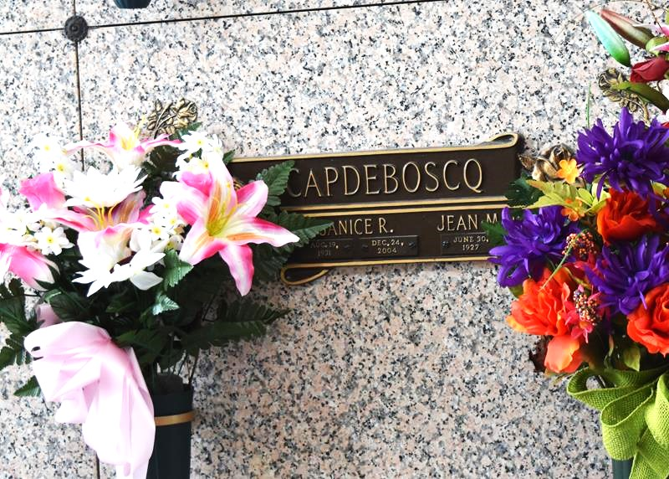

Jean M. “Cap” Capdeboscq Jr., 85, passed away Monday, May 27, 2013. He was the beloved husband of the late Janice Lassere Capdeboscq, and father of John, Karen, Kerry and Geralyn Capdeboscq and Lisa Landeche. He is also survived by nine grandchildren. He was a native of Marrero and a resident of LaPlace.

Relatives and friends are invited to attend services. Visitation will be held at Millet-Guidry Funeral Home, 2806 W. Airline Highway, LaPlace, on Thursday, May 30, 2013, from 8 a.m. to 10 a.m., followed by religious services in the funeral home chapel at 10 a.m. Burial will follow in St. John Memorial Gardens in LaPlace.  
  
L’Observateur, LaPlace, Louisiana

Tuesday, May 28, 2013