Dolores (Izada) Cardenas

October 24, 1948 – April 30, 2015

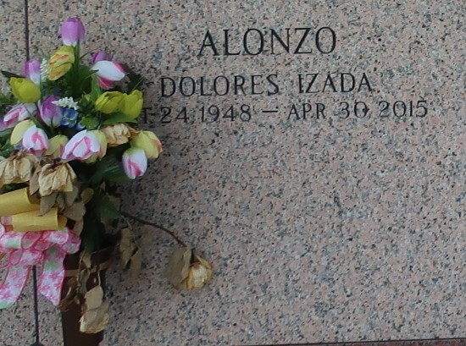

Dolores Izada passed away on Thursday, April 30, 2015. She was 66, a native of Oriente, Cuba and a resident of Metairie, LA. Beloved wife of the late Fidel Horacio Cardenas. Mother of Marco Cardenas (Patricia), Olga Alonzo (Danny), Alberto Montero-Izada (Tiffany) and William Izada. Daughter of the late Juana Ibanez and Jose Izada. Sister of the late Migdalia Rojas. Grandmother of Angelica, Shawn, Corey, and Danny Alonzo, Jr., and Braylon and Braxton Montero-Izada. Great-grandmother of Makenzie and Miley Alonzo.

Relatives and friends are invited to attend the Funeral Mass at St. Joan of Arc Catholic Church, 529 W. 5th St., LaPlace on Thursday, May 7, 2015 at 11:30 a.m. Visitation will begin in church at 10:00 a.m. Interment in St. John Memorial Gardens Cemetery. Arrangements by Millet-Guidry Funeral Home. To view or sign the online guest book, please visit [www.milletguidry.com](http://www.milletguidry.com/)

The New Orleans Advocate (LA)

May 5 to May 6, 2015