John C. Carter

June 5, 1940 – February 12, 2017

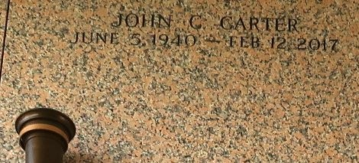

John C. "Soul" Carter at the age 76 yrs departed this earthly life and entered into eternal rest on Sunday February 12,2017 at Canon Hospice in Metairie, La. Son of the late Desra and Ethel Green Carter Favors. Loving Brother of Eula Watkins of LaPlace, La. Andrew Favors of Baltimore, Md. and Larry Favors of LaPlace, La. Also survived by a host of nieces, nephews other relatives and friends. A native and resident of LaPlace, La.

Relatives and friends of the family also Pastors and Officers of Mount Nebo Baptist Church of LaPlace, La and all neighboring churches are invited to attend the home going celebration on Saturday February 18,2017 at 10am at Mount Nebo Baptist Church 198 W. 2nd St. LaPlace, La Pastor Augutus G. Brown Jr. officiating. Interment in St. John Memorial Garden of LaPlace, La . Visitation will be at the above name church from 8am until service time. Bardell's Mortuary of Mt. Airy, La in charge. Information: 985-535-6837.

The New Orleans Advocate, Louisiana

Feb. 16 to Feb. 18, 2017