Max Leon Catoire

November 20, 1934 – November 12, 1999

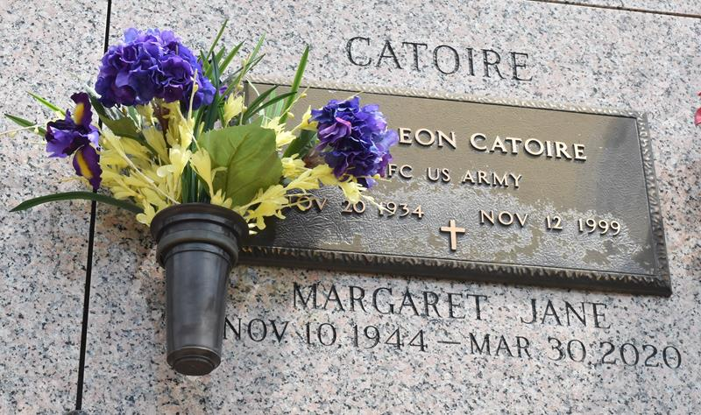

LAPLACE Max "Bear" Catoire, 64, a native and resident of LaPlace, died Nov. 12. He was the husband of Margaret James Catoire and father of Wesley Catoire. He was also the son of the late Leon and Birdie Catoire and brother of Jean McKinney, Dixie Rome, Patsy Oubre and Jack Dempsey Catoire.

Services are today at 10 a.m. in the chapel of Millet-Guidry Funeral Home, LaPlace, with interment at St. John Memorial Gardens, LaPlace. Visitation starts at 8 a.m.

L'Observateur, LaPlace, Louisiana

November 17, 1999