Ethel (Hatfield) Cavalier

July 30, 1933 – October 20, 2000

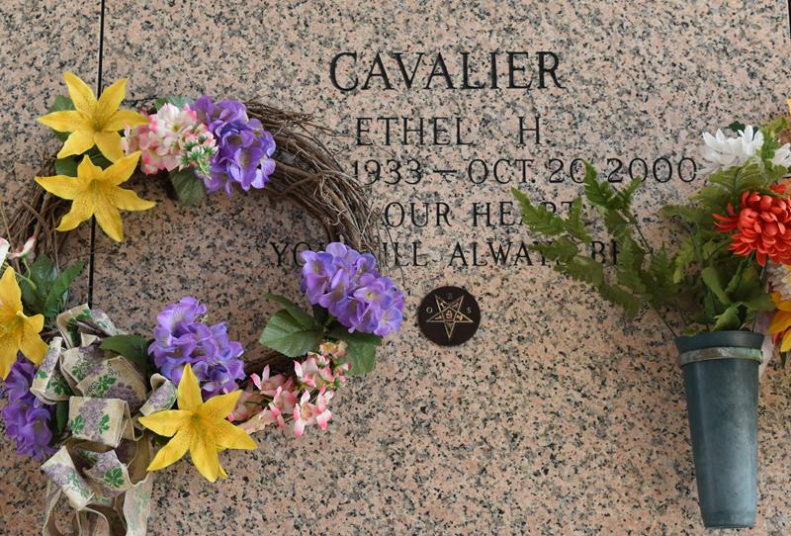

LAPLACE - Ethel Hatfield Cavalier, 67, a native of Garyville and resident of Norco for 48 years, died Oct. 20. She was the wife of E.J. Cavalier and mother of Wanda Powe and Jewel Watts Jr. She was also the daughter of the late Thomas and Army Hatfield and sister of Elsie Montz and Thomas Hatfield Jr. She is also survived by four grandchildren and one great-grandchild.

Services were held Oct. 23 in the chapel of Millet-Guidry Funeral Home, LaPlace, with interment at St. John Memorial Gardens, LaPlace.

L'Observateur, LaPlace, Louisiana

October 25, 2000