Eunice (Rodriguez) Chaisson

September 29, 1944 – January 2, 2013

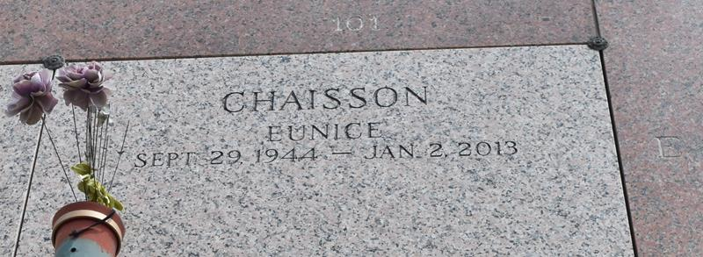

Eunice Chaisson passed away on Wednesday January 2, 2013. Beloveed wife of Carl Chaisson. Mother of Tracy Vollenweider (Steven), Michael Chaisson (Alicia) and Carl Chaisson Jr.(Mandy). Also 6 grandchildren. Daughter of Willie and Eunice Rodriguez. Sister of the late Sally Roberts. Age 68. A native of Norco, LA and a resident of LaPlace, LA.

Relatives and friends are invited to attend services. Visitation at Millet-Guidry Funeral Home, 2806 W. Airline Hwy. LaPlace, LA on Friday January 4, 2013 from 8:00 am to 10:00 am followed by Religious Services in the Funeral Home Chapel at 10:00 am. Burial in St. John Memorial Gardens Cemetery, LaPlace, LA.

The Times-Picayune, New Orleans, Louisiana

Jan. 2 to Jan. 4, 2013