Joseph R. Charles

June 23, 1932 – December 20, 2003

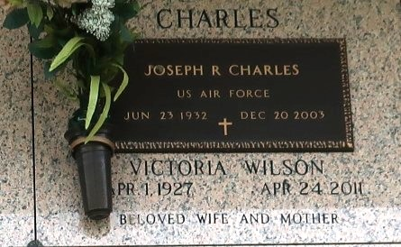

Joseph Charles on Saturday, December 20, 2003 at Canon Hospice, Jefferson, LA. Son of the late Lucille Kirchard and Willie Charles. Husband of Victoria W. Charles. Father of Desiray, Sabrinna and Casandra Charles. Stepfather of Carol L. White and James Lewis. Brother of Harold Charles, the late Willie Charles, Jr. and Melvina Richardson. Also survived by 11 grandchildren, 9 great grandchildren and a host of nieces, nephews, other relatives and friends. Age 71 years. A native of New Orleans, LA and a resident of Laplace, LA.

Relatives and friends of the family are invited to attend the funeral service at Robottom Mortuary, 850 Highway 44, (River Road), Reserve, LA on Saturday, December 27, 2003 at 11:00 AM. Interment St. John Memorial Garden Cemetery, Laplace, LA. Visitation at the above named funeral home from 10:00 AM until service time. SERVICED BY ROBOTTOM

The Times-Picayune, New Orleans, Louisiana

December 26, 2003