Victoria (Wilson) Charles

April 1, 1927 – April 24, 2011

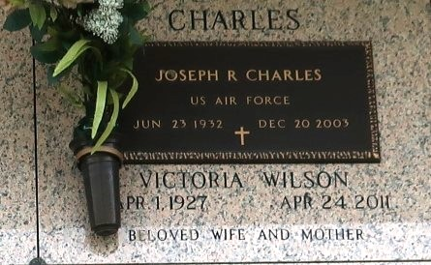

Victoria Wilson Charles on Easter Sunday, April 24, 2011 at 2:30 in the afternoon, surrounded by her family, at her daughter's home in Paradis, LA returned to her Heavenly Father. Daughter of the late Willie Wilson, Sr. and Vivian B. Wilson of LaPlace, LA. Beloved wife of the late Joseph Charles. Mother of James Lewis and Carol White. Mother-in-law of Elaine Lewis and Donnie White. Sister of Willie Wilson, Jr., Leonard Wilson, Donald Ray Wilson and the late Ignatius Wilson. Sister-in-law of Viola Wilson, the late Elnora Wilson, Audrey Wilson and Geraldine Wilson. Godmother of Mary Ann Parquet, Rhonda Cammon and Ashley Richard. Dearly loved friend of Carrie Forest and Rosalind Johnson. Also survived by 7 grandchildren, 15 great-grandchildren and a host of nieces, nephews, in-laws, cousins, other relatives and friends. Age 84 years. A native of LaPlace, LA and a resident of Paradis, LA.

The Matriarch of the family, Victoria was a devout Catholic, a member of the Knights of Peter Claver Ladies Auxiliary St Catherine Court #73, and LHP Social Aide and Pleasure Club. Employed with Crystal Preservatives and retired from American Bank. A loving mother, grandmother, friend, and caregiver of many.

Relatives and friends of the family, also priests and parishioners of Our Lady of Grace Catholic Church and all neighboring churches are invited to attend the Mass of Christian Burial at Our Lady of Grace Catholic Church, 772 Highway 44, Reserve, LA on Saturday, April 30, 2011 at 10:00 AM. Father Joseph Rodney, Celebrant. Interment St John Memorial Gardens, 2205 West Airline Highway, LaPlace, LA. Visitation at the above named church from 9:00 AM until Mass time. Holy Rosary at 9:30 AM. The family requests, in lieu of flowers, donations are made to the American Diabetes Association, P.O. Box 11454, Alexandria, VA 22312 or

<http://www.diabetes.org/donate/> in memory of Victoria Wilson Charles. SERVICED BY ROBOTTOM.

The Times-Picayune, New Orleans, Louisiana

April 29, 2011