William Joseph Chauvin
August 5, 1926 – August 27, 2022

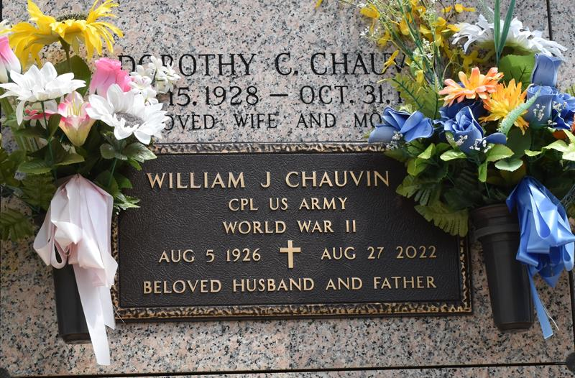

William Joseph Chauvin, Jr. passed away on Saturday, August 27, 2022 at the age of 96. He was a native of Union, LA, a resident of LaPlace, LA and a U.S. Army Veteran having served his country during World War II.
He is our favorite daddy and the best Paw Paw ever. He loved camping and fishing, but most of all spending time with his family. Our New Year s Christmas will never be the same. His thoughtful gifts and notes with instructions are treasures beyond compare. Although he left his earthly home surrounded by his loving family, we have faith that he has been welcomed into God s kingdom.
Dad is now with his loved ones who have gone before him, especially Dot, his beloved wife of 47 years. Daddy, we pray that you find that gold and there are many beautiful mountains and streams for you both to enjoy. Our family is still growing, and mama and daddy will forever be our angels watching over all of us. Until we can be together again, live like dad and go with the flow. All our love, sons number 1, 2 and 3, your little girl, grandchildren and great-grandchildren.
Beloved husband of the late Dorothy Dot Clouatre Chauvin. Loving father of Tom Chauvin, Kenny Chauvin, Glenn Chauvin (Vanessa) and Donna Minchey (Terry). Grandfather of Bridgett Chauvin, Nicole Weber (Brandon), Andy Chauvin, Jamie Chauvin, Matthew Chauvin, Olivia Mang, Jonathan Cavell (Tiffany) and David Cavell. Great grandfather of Mackenzie, Kayla, Calie, Dylan, Connor, Noah and George. Son of the late Gussie Bourque Chauvin and William Joseph Chauvin, Sr. Brother of Gary Chauvin (Herminie), Doris Brignac (Francis) and the late Betty Chauvin, Wilbert Chauvin, Alfred Chauvin (Mildred), Daisy Clouatre (Andrew), and Bernice Canatella (Nick). Also survived by a host of nieces and nephews.
Relatives and friends are invited to attend the Visitation at Millet-Guidry Funeral Home, 2806 W. Airline Hwy., LaPlace on Tuesday, August 30, 2022 from 6:00 p.m. to 9:00 p.m. and on Wednesday, August 31, 2022 from 9:00 a.m. to 11:00 a.m. followed by a Funeral Service at 11:00 a.m. Interment in St. John Memorial Gardens Cemetery, LaPlace, LA.
In lieu of flowers, donations can be made in his memory to the Southeast Louisiana War Veterans Home, 4080 W. Airline Hwy., Reserve, LA 70084 or the charity of your choice. To share memories or condolences, please visit www.milletguidry.com
Millet-Guidry Funeral Home, LaPlace, Louisiana
August 29, 2022

