Henry Lavell Childress

February 10, 1945 - September 25, 2020

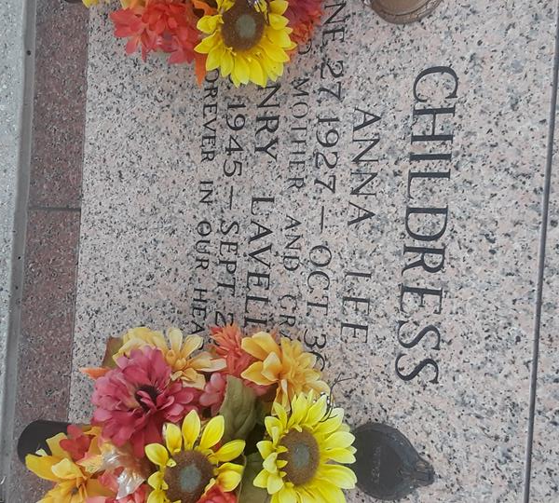

Henry Lavell Childress, Sr. passed away on Friday, September 25, 2020 at the age of 75. He was born in Rayville, LA and was a longtime resident of LaPlace. Henry retired from International Union Operating Engingeers Local 406 as a crain operator. He was an former member of Masonic Lodge F&AM Chapter 111 in Picayune, MS.

Beloved husband of 58 years to Sharon Hebert Childress. Loving father of Henry Lavell Childress, Jr. (Alva), Keith E. Childress (Jan), Tonuya C. Moreau (Kenneth), and Tammy C. Duhon (Torrey). Grandfather of Shane, Sasha, Ryan, Taylor, Amanda, Justin, Miranda, Kaitlyn, and Brianne. Great grandfather of 8 grandchildren and the late Shane L. Childress, Jr. Son of the late Henry Rand Childress and Anna Lee Howard Childress. Brother of Nolan R. Childress and the late Judy C. Wood. Also survived by nieces and nephews.

The family would like to give a special thanks to Ascension Oaks Nursing Home and Staff, and Mandy Starns with Hospice of Baton Rouge for their wonderful care and compassion.

Relatives and friends are invited to attend the Funeral at Millet-Guidry Funeral Home, 2806 W. Airline Hwy, LaPlace on Wednesday, September 30, 2020. Visitation will be held from 9:00 a.m. to 11:00 a.m. with the service to immediately follow at 11:00 a.m. Internment to follow in St. John Memorial Gardens Cemetery.

Millet-Guidry Funeral Home, LaPlace, Louisiana

September 27, 2020