Jayden Micheal Christopher

December 18, 2009 – August 27, 2021

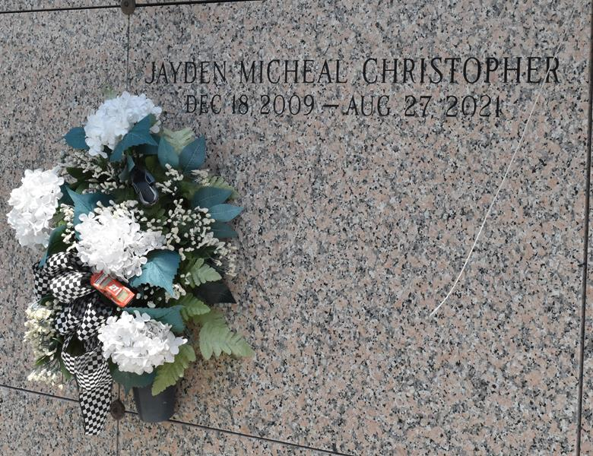

Unrestrained Juvenile Killed in St. James Parish Crash

Vacherie – On August 27, 2021, shortly after 9:00 PM, Louisiana State Police Troop C was notified of a two-vehicle fatal crash on Louisiana Highway 3127 about 1 mile west of LA 20 in St. James Parish. The crash claimed the life of 11-year-old Jayden Christopher of Laplace.

The preliminary investigation revealed a 2006 Nissan Sentra, driven by Jacqualine Christopher of Laplace, was traveling east on LA 3127. For unknown reasons, the Nissan crossed the centerline and struck a westbound 2018 Toyota Camry head-on. After the collision, the Toyota became engulfed in flames. Both the driver and front passenger of the Toyota were removed from the vehicle before sustaining injuries due to the fire.

Jayden Christopher, who was the front seat passenger in the Nissan, was unrestrained at the time of the crash and suffered fatal injuries. He was pronounced dead on the scene by the St. James Parish Coroner’s Office. Jacqualine Christopher, who was also unrestrained at the time of the crash, suffered moderate injuries. Both front occupants of the Toyota also suffered moderate injuries during the crash. Due to the severity of the Toyota’s damage, seatbelt usage is unknown at this time.

Toxicology samples were collected from the drivers for analysis. This crash remains under investigation.

Louisiana law requires all vehicle occupants to be properly restrained in all seating positions day or night. The law also requires children under the age of 13 to be transported in the rear seat of a motor vehicle, when one is available.

Louisiana State Police

Troop C News Release

August 28, 2023