Annabell Marie (Frank) Claiborne

September 1945 – February 6, 2018

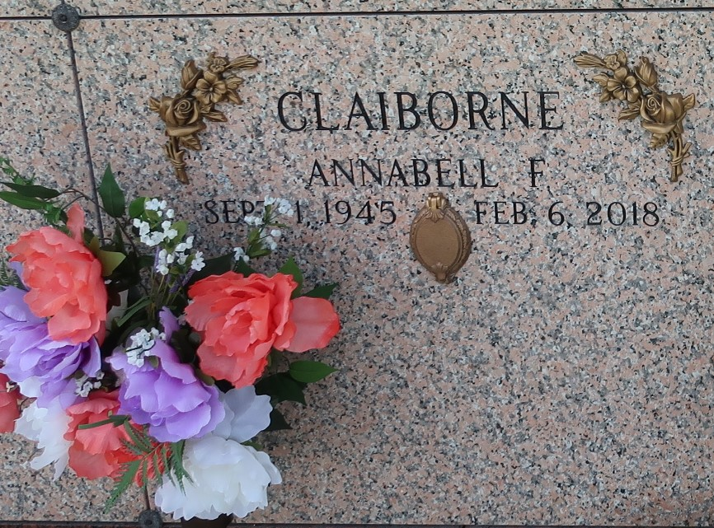

Annabell Marie Frank Claiborne departed this life on Tuesday, February 06, 2018, daughter of the late Cecile & Wallace Frank, Jr, beloved wife of Lionel Claiborne, beloved Mother of Artee Claiborne and Anica (Egerald) Matthews, grandmother of Allegra and Aliza Bovie, Sister of Raymond and Ronald (Papa) Frank and the late Wallace Frank III, daughter in law of the late Eli and Eula Mae Claiborne. Annabell is also survived by a host of others relatives and friends.

Relatives and friends of the family are invited to attend the home going service on Saturday February 17, 2018 at 10:00 am from Bethlehem B.C. 147 E.20th St. Reserve, La., Rev. Forell Bering Sr. Host Pastor, Bishop Ronald Frank officiating. Visitation at the church on Saturday from 8:30 am until service time ONLY. Interment in St. John Memorial Cemetery. Laplace, LA. Service entrusted to HOBSON BROWN FUNERAL HOME, 134 DAISY ST. GARYVILLE, LA. 985-535-2516

The New Orleans Advocate, Louisiana

Feb. 15 to Feb. 17, 2018