Archille Clark Jr.

February 29, 1940 – November 3, 2021

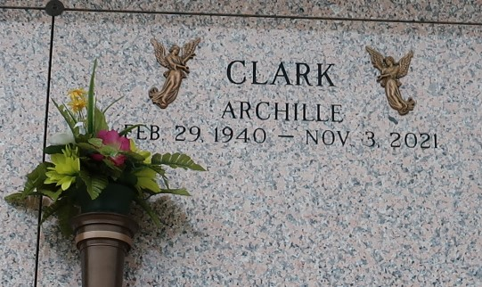

On February 29, 1940, God lovingly dispatched Archille Clark, Jr., on wings of angels, to this world into the loving arms of his mother and father, Dora and Archille Clark, Sr. He departed this life on Wednesday, November 3, 2021. He accepted Christ as his Lord and Savior and was baptized by the late, Rev. Dr. Joseph C. Profit, Jr., Stronger Hope Baptist Church, New Orleans, LA. Archille graduated from Prairieville High School. After graduation, he relocated to New Orleans, LA. He was united in Holy Matrimony to Joyce Vallery. During this marriage, two children were born: Eric and Kevin.

He later relocated to Gonzales and joined First Pilgrim Calvary Missionary Baptist Church. Archille was later united in Holy Matrimony to Betty Lewis. He and Betty enjoyed life together. The two moved to Reserve, LA, and joined First Community Antioch Baptist Church in Lutcher, LA, where he was currently serving until his health began to fail. Archille was actively involved in his church. He served on the Deacon and Trustee Boards and with the Men's Ministry. He taught Sunday School, Vacation Bible School, Youth Bible Study, and with the Prayer Ministry. He was a great asset in many capacities to his church and church family.

Archille is survived by his wife, Betty Lewis Clark, Reserve, LA; one son, Eric Kenneth Clark (Ullana), Dallas, Tx; one daughter, Donna Dillon (James), Columbia, Ms; seven sisters: Fannie Sharper (Booker), Mary Lily Carter (Edward), Dora Lunkin, Ruth Melancon (Joseph) all of Gonzales, LA, Carrie Watis, Convent, LA, Ruby Duckett (Herman), Westwego, LA, and EllenPerkins (Wayne), Baytown, Tx; two brothers: Cornelius Clark (Burnedette) and Henderson Clark (Juanita), Gonzales, LA; four grandchildren: Shaleah Clark, E.J. Clark, Aliyah Clark, and Lakisha Dillon; a great-grandson, Christin Juan Dillon; five Godchildren, Bernadette Marie Philip, Carl Favorite, Jr., Troy Favorite, Myron Christopher, and Jackie Christopher.

He was preceded in death by his parents; maternal and paternal grandparents; sisters: Odeal Cooper, Sarah Miller, and Linda Johnson; brothers: Clarence, Ben, Ernest, John, and Phillip Clark; and a son, Kevin Tyrone Clark.

A celebration of life honoring Archille Clark Jr. will be held on Saturday, November 13, 2021, at First Community Antioch Baptist Church, 10860 LA-3125, Lutcher, LA 70071 at 10am. Visitation period will be held from 8am-10am. Entombment to follow at St. John Memorial Gardens, 2205 W Airline Hwy, LaPlace, LA 70068. Final care and professional services entrusted to Treasures of Life Funeral Services, 315 E Airline Hwy, Gramercy, LA 70052. To share condolences and thoughts, and to sign guest book, please visit: www.treasurefunerals.com. Due to COVID-19 and CDC guidelines and restrictions, masks and social distancing are REQUIRED!!

Treasures of Life Funeral Services, Gramercy, Louisiana