Amy (Tabor) Clement

September 21, 1915 – June 27, 2002

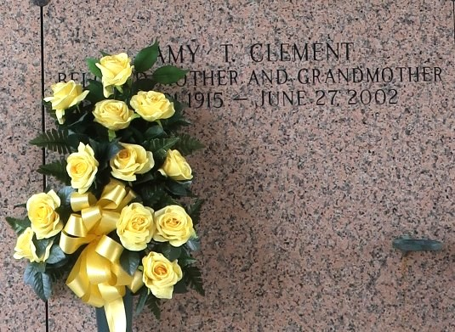

Amy Tabor Clement, on Thursday, June 27, 2002, at 10:30 P.M. Beloved Wife of the late Gustave Clement, and by first marriage of the late Wilford Chenier, Jr. Mother of Ricky Chenier, Barbara Bourgeois, Geri Weber and Joyce Murry. Daughter of the late Albert and Helene Tabor. Sister Of Ruby Hebert And Claude Tabor. Also Survived By 12 Grandchildren 23 Great-Grandchildren And 1 Great-Great-Grandchild. Age 86, A Native Of Choctaw La And A Resident Of Laplace La For The Past 80 Years  
  
Relatives And Friends Of The Family Are Invited To Attend The Services Visitation At Millet-Guidry Funeral Home 2806 West Airline Hwy Laplace La On Sunday June 30-2002 From 5 Pm To 10 Pm And On Monday July 1-2002 From 8 Am Until 9:45 Am Followed By Religious Services At St Joan Of Arc Catholic Church Laplace La At 10 Am Burial In St John Memorial Gardens Cemetery Laplace La

The Times Picayune, New Orleans, Louisiana

June 29, 2002