Calvin G. Clement Sr.

February 15, 1925 – November 16, 2010

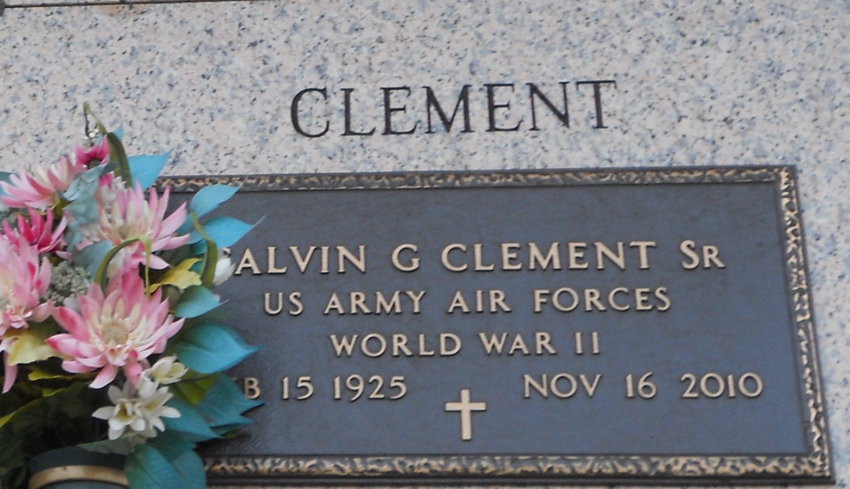

Photo by Team T Lo

Calvin G. Clement passed away on Tuesday, November 16, 2010. Beloved husband of Thelma Cortez Clement. Father of C.J. Clement (Rosalind), Nancy C. LeBlanc (Keith), Brenda C. Callahan (Jimmy) and Bonnie Voelkel (Larry). Also survived by 10 grandchildren and 5 great-grandchildren. Son of the late Paul and Ora Clement. Brother of Helen C. Zito and the late Teddy and Paul Clement. Age 85. A native of St. Rose, La. and a resident of LaPlace, La.

Relatives and friends are invited to attend services. Visitation at Ascension of Our Lord Catholic Church, 1809 Greenwood, LaPlace, La. on Friday, November 19, 2010 from 10:00 a.m. to 12:00 noon followed by Mass at 12:00 noon. Burial in St. John Memorial Gardens Cemetery, LaPlace, La. Arrangements by Millet-Guidry Funeral Home, LaPlace, La.  
  
The Times Picayune (LA)