Gerald John Clement Sr.

October 17, 1934 - December 29, 2021

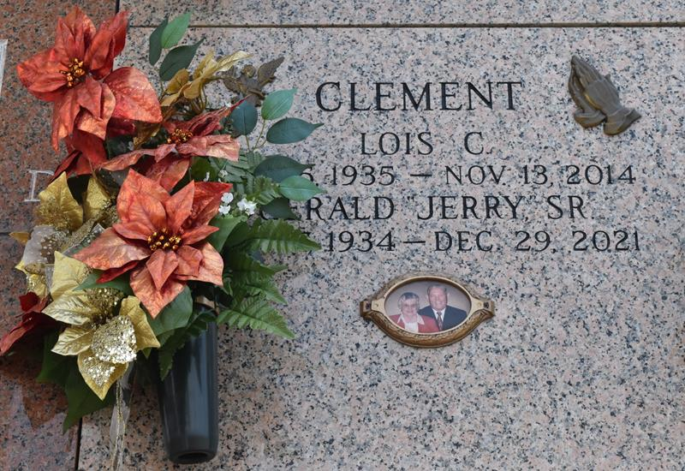

Gerald John 'Jerry' Clement, Sr. passed away on Wednesday, December 29, 2021. He was 87, a native and lifelong resident of LaPlace, LA. Jerry retired from Shell Chemical in after 37 years of service.

Beloved husband of the late Lois Clement. Father of Gerald 'Jerry' Clement, Jr. (Ann), Kim Clement (Tina) and Todd Clement, Sr. (Alisha). Son of the late Aline Melancon Clement and William Lionel Clement, Sr. Brother of Carmen Weber and the late Juliette Alford, Daniel Clement, Lilly Starkes, Nina Scalco, William Clement, Jr., Helen Satterlee, Melba Catoire, Roy Clement and Elizabeth Cehlar. Grandfather of Lorelie Clement Roussel, Sarah Clement Aledort, Samantha Clement, Todd Clement, Jr., Justin Clement, Heather Clement, Hannah Clement and Heaven Clement. Also survived by 4 great grandchildren.

The family would like to express their heartfelt appreciation to Alisha Clement for her loving care.

Relatives and friends are invited to attend the Funeral. A Funeral Mass will be celebrated at St. Joan of Arc Catholic Church, 529 West 5th Street, LaPlace on Thursday, January 6, 2022 at 11:30 a.m. Visitation at the church from 9:30 a.m. until 11:30 a.m. Interment in St. John Memorial Gardens Cemetery, LaPlace.

Millet-Guidry Funeral Home, LaPlace, Louisiana

January 1, 2022