Lillie Mae Clement

May 30, 1936 – March 6, 2004

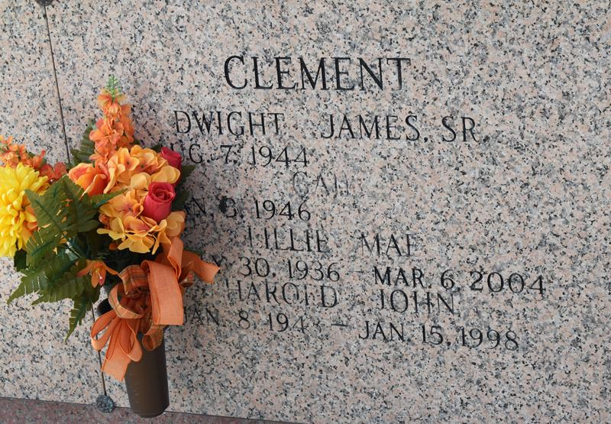

Lillie Mae Clement On Saturday, March 6, 2004 At 3:00 Pm. Beloved Daughter Of The Late Lawrence (Loule) And Simone Vicknair Clement. Sister Of Daniel Clement And Marian C. Prudhomme Of Laplace, Faye C. Marse Of Reserve And The Late L.J., Harold, Dwight And Lorraine Clement. Aunt Of Paula, Perry, Tammy, Dwight, Jr., Thad, Jason, Ratchel And Kenny, Jr. Great Aunt Of Lester, Iii, Heather, Kyle, Perry, Jr., Mandy, Raelyn, Dayton, Amber, Wyatt, Brittney, Shane, Mason, Hunter And Michael.

Also Special Thanks To Twin Oaks Staff And Administration, River Parish Hospital, Cannon Hospice, Dr. Andy St. Martin And Dr. Christy Montegut. Age 67 Years. A Resident Of Laplace.

Visitation At Millet Guidry Funeral Home, 2806 W. Airline Hwy., Laplace, La. On Tuesday, March 9, 2004 At 9am To 11am. Followed By Religious Services In The Funeral Home Chapel At 11am. Burial In St. John Memorial Gardens Cemetery, Laplace.

The Times-Picayune, New Orleans, Louisiana

March 8, 2004