Lois Joan Clement

January 25, 1935 – November 13, 2014

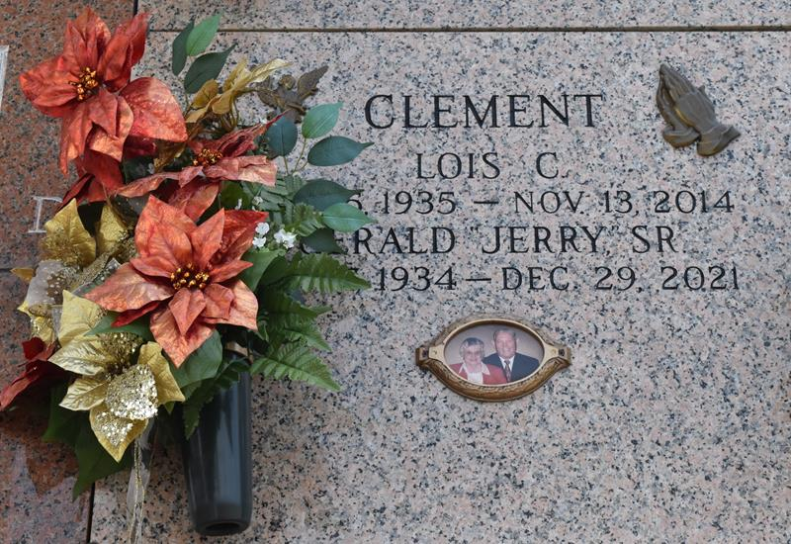

Lois Joan Clement passed away surrounded by her loving family on Thursday, November 13, 2014. She was 79, a native and resident of LaPlace. Beloved wife of Gerald ‘Jerry’ Clement, Sr. for 58 years. Loving mother of Gerald ‘Jerry’ Clement, Jr. (Ann), Kim Clement (Tina), Todd Clement, Sr. (Alisha). Daughter of the late Clarence ‘Clan’ Clement and Mae Clement. Sister of Iris Palermo and the late Barbara Baker, Darrel, Lloyd, Dale and Richard Clement. Grandmother of Lorelei Roussel, Todd, Jr., Sarah, Samantha, Justin, Heather, Hannah and Heaven Clement. Great-grandmother of Julia Clement and Phoenix Roussel. She is also survived by numerous nieces and nephews.

Special thanks to Todd Clement, Sr. Alisha Clement, Linda Waguespack and Jan Townsend during her illness. She was loved by all and will be greatly missed.

Relatives and friends are invited to attend the Funeral Mass at St. Joan of Arc Catholic Church, 529 W. 5th St., LaPlace on Tuesday, November 18, 2014 at 11:30 a.m. Visitation will begin in church at 9:30 a.m. Interment in St. John Memorial Gardens Cemetery. Arrangements by Millet-Guidry Funeral Home.

Millet-Guidry Funeral Home, LaPlace, Louisiana