Richard J. Clement

August 4, 1946 – February 2, 2009

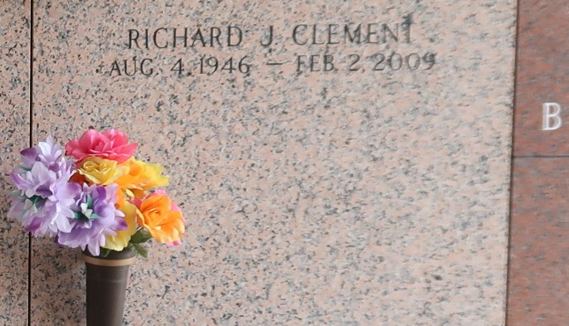

Richard J. Clement died on February 2, 2009 at River Parishes Hospital.  
Age 62, he was a native of LaPlace, La and worked in construction as a bricklayer, pipefitter and welder.  
  
Survivors include two sons; Donny Clement and his wife, Rosalind of LaPlace; Ronald Clement and his wife, Brandy of Reserve. Brother, Darrold Clement of Reserve. Sisters; Lois Clement and her husband, Jerry of LaPlace and Iris Palermo of LaPlace. Grandchildren, Justin and Kaleb Clement. Step-grandchildren; Matthew and Lauren Hermann. Great-Grandson, Jorden Clement and step-great-granddaughter, Jada Hermann.  
  
Preceded in death by: Parents; Clarence Clement and Mae Thibodeaux Clement; Brothers; Dale Clement and Lloyd Clement. Sister; Barbara Baker. Special friend and ex-wife Shirley Gautreaux.  
  
Visitation on Thursday, February 5, 2009 at the H. C. Alexander Funeral Home inNorco from 9:00 am until 11:00 am. Funeral service will be held at 11:00 am with Fr. Ed Lauden officiating. Interment will follow in the St. John Memorial Mausoleum in LaPlace. FUNERAL ARRANGEMENTS UNDER THE DIRECTION OF H. C. ALEXANDER FUNERAL HOME IN NORCO, LA. The family invites you to share your thoughts and fond memories in the Guest Book at www.mem.com.   
  
The Times-Picayune, New Orleans, Louisiana

February 4, 2009